**Lesson 9 Study Guide**

**Big Ideas:**

1. **How do I divide decimals using long division?** 
   1. **Whole number divisor (dividing a decimal number by a whole number)**
      1. **Decimal in quotient goes directly above decimal in dividend**
   2. **Decimal divisor (diving a whole number or decimal number by a decimal number)**
      1. **Determine which power of ten to multiply the divisor by to get a whole number divisor**
      2. **Move the decimal (10=1 time, 100=2 times, 1000=3 times, etc.)**
      3. **Do the same to the dividend (add zeros if necessary)**
      4. **Rewrite the problem, and divide**
2. **How can I check my quotient?**
   1. **Multiply quotient by divisor in original problem to get your dividend**
3. **VOCAB:**

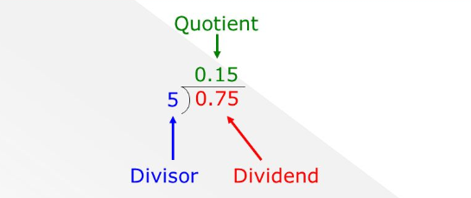

Practice:

1. **Pick any decimal numbers to divide**
   1. Practice word problems as well (ex. if I have a rope that is 18.3 feet long and want to cut it into equal pieces of 0.3 feet, how many pieces would I have?)
2. Use knowledge of fact families to determine missing factors, divisors, or dividends
   1. _____ x 1.5 = 0.225 (Find the missing factor by dividing 0.225 by 1.5)
   2. 2.4 ÷ ____ = 0.3 (Find the missing divisor by dividing 2.4 by 0.3)
   3. _____ ÷ 0.16 = 2. 8 (Find the missing dividend by multiplying 2.8 by 0.16)