**Lesson 10 Study Guide**

**Big Ideas:**

1. **How do I add and subtract fractions?** 
   1. **\*\*You cannot add or subtract fractions unless the denominators are the same!**
   2. **Find the lowest common denominator by listing multiples of each denominator**
      1. **You can find a quick common denominator by multiplying the two denominators**
   3. **Rewrite the original fractions using equivalent fractions with the common denominator**
   4. **Add or subtract the numerators; the denominator stays the same**
      1. **Simplify if possible!**
2. **VOCAB:**

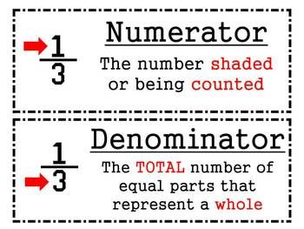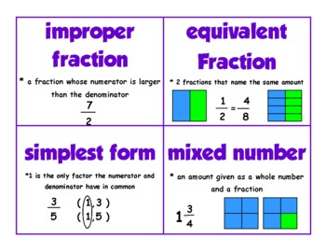

Practice:

1. **Pick any fractions to add and subtract**
   1. Practice word problems as well (ex. John has a rope that is 3 $\frac{2}{5}$ meters long and Lyla has a rope that is 1 $\frac{3}{4}$ meters long; how much longer is John’s rope? Or how much rope do they have combined?)
   2. Include some addition problems with three fractions of different denominators