**Lesson 12 Study Guide**

**Big Ideas:**

* **Important: All fractions can be written as division problems and all division problems can be written as fractions (ex. $\frac{7}{3}$ is 7 $÷$ 3)**

1. **How do I write an improper fraction as a mixed number?**
   1. **Set up long division and divide to get a remainder (if there is one)**
   2. **Quotient is whole number part of mixed number**
   3. **Remainder is numerator of fraction part**
   4. **Divisor is denominator**

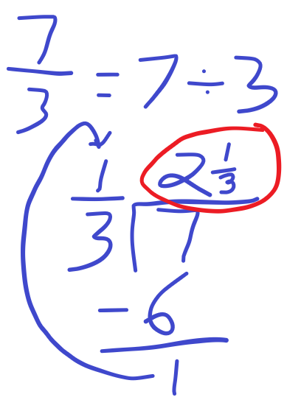

1. **How do I determine which order to divide in word problems? (Hint: It is not always the bigger number divided by the smaller number!)**
   1. **Look for what in the problem is being shared or grouped equally (what is being “broken apart”-this is your dividend)**

Practice:

1. **Pick improper fractions to convert to mixed numbers, and vice versa**
2. **Word problems (ex. “3 friends share 8 candy bars evenly. How many candy bars does each friend get?”)**