**Lessons 17 and 18 Study Guide**

**Big Ideas:**

1. **How do I divide with fractions?**
   1. **Fraction ÷ Fraction**
   2. **Whole number ÷ Fraction**
   3. **Fraction ÷ Whole number**

**Remember: To write a whole number as a fraction, whole number is numerator and denominator is 1**

**Step 1: Leave the dividend (first number) the same**

**Step 2: Turn the division sign into a multiplication sign**

**Step 3: Flip the divisor (second number)**

**Ex. $\frac{2}{5}$ ÷ 3 = $\frac{2}{5}$ x $\frac{1}{3}$ = $\frac{2}{15}$**

**Vocab.: Reciprocal – flip a fraction (reciprocal of $\frac{2}{3}$ is $\frac{3}{2}$)**

1. **What does dividing fractions look like using a model?**

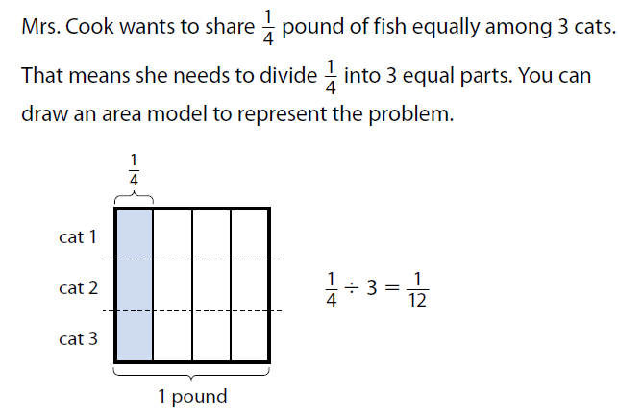

Practice:

1. **Pick whole numbers to divide by fractions and fractions by whole numbers**
2. **Pick fractions to divide by fractions**
3. **Practice simplifying fractions!**
   1. **Find the Greatest Common Factor (or any common factor until there are none left) to divide both numerator and denominator**