**Lesson 19 Study Guide**

**Big Ideas:**

1. **How do I use the order of operations to solve word problems involving multiple operations?**

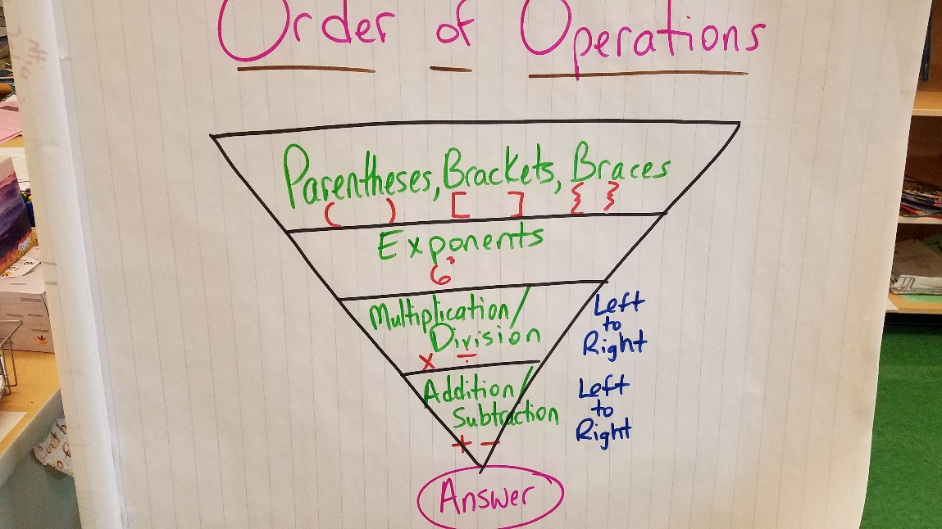

1. **How do I write an expression to represent a multi-operation problem?**
   1. **Ex. “George has 4 parrots and 6 parakeets. Lisa has three times the number of birds George has. Write an expression to represent how many total birds Lisa has.” 3 x (4 + 6) or (4 + 6) x 3**

**VOCAB:**

**sum: the answer to an addition problem**

**difference: the answer to a subtraction problem**

**product: the answer to a multiplication problem**

**quotient: the answer to a division problem**

**brackets: [ ] braces: { }**

Practice:

1. **Videos and practice problems on Khan Academy:** [**https://www.khanacademy.org/math/cc-fifth-grade-math/cc-5th-algebraic-thinking#cc-5th-writing-expressions-tut**](https://www.khanacademy.org/math/cc-fifth-grade-math/cc-5th-algebraic-thinking#cc-5th-writing-expressions-tut)
2. **Practice solving expressions with different operations**