**Lesson 20 Study Guide**

**Big Ideas:**

1. **How do I determine rules for patterns, and how do I write patterns using rules? (ex. start at 0 and use the rule “add 6” looks like 0,6,12,18,24…)**
2. **How do I determine the relationship between corresponding terms of two patterns? (ex. “Each term in pattern B is ________ the corresponding term in pattern A”)**
3. **How can I graph ordered pairs using two patterns?**

**VOCAB:**

**corresponding terms: numbers that have the same position in two related patterns**

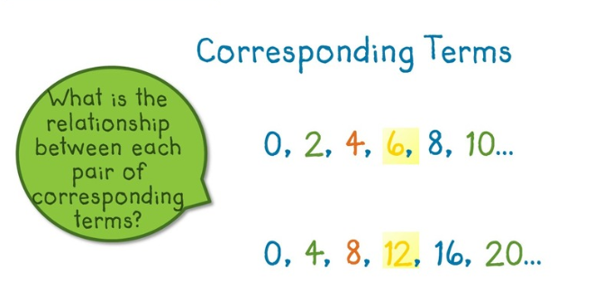

**ordered pair: a pair of numbers (x,y) that describe the location of a point on a coordinate plane**

Practice:

1. **Videos and practice problems on Khan Academy: https://www.khanacademy.org/math/cc-fifth-grade-math/cc-5th-algebraic-thinking#cc-5th-number-patterns**
2. **Provide two patterns and have kids identify each pattern’s rule and the relationship between corresponding terms**
3. **Create a coordinate plane and graph ordered pairs (x first, then y!)**