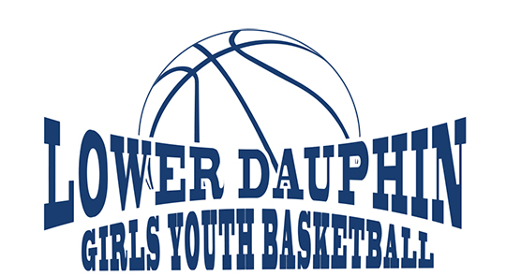
2019-2020 LD GIRLS YOUTH BASKETBALL REGISTRATION
For girls in K – 2nd grade in the Lower Dauphin School District

An introduction to basketball for girls in Kindergarten, 1st or 2nd grade living in the Lower Dauphin School District. Sessions include drills for dribbling, passing, catching, shooting, offense and defense. We make having fun the top priority. Each player will receive a basketball to use at the skill sessions and T-shirt.

The schedule will be posted online at LDYouthHoops.com by October 31, but generally practices will be Mondays from 6-7pm at Nye Elementary from November through February.

Cost is $65 for one player, $100 family (2 or more players). IF YOU ARE WILLING TO COACH (must have school volunteer clearances), FEE WILL BE REFUNDED>>>>SEE BELOW.

We will host a registration night/open house on October 15th at South Hanover from 5:00-5:30pm to answer any questions you might have prior to registering.

Please COMPLETE and RETURN by October 20. Make checks payable to Lower Dauphin Girls Youth Basketball. Mail to: LDGYB, 51 Oaktree Road, Hummelstown PA 17036.
Contact LDGirlsYouthBasketball@gmail.com with any questions.

**THIS PROGRAM IS NOT SPONSORED OR ENDORSED BY THE LOWER DAUPHIN SCHOOL DISTRICT**
*********************************detach and mail**********************************

Child’s Name________________________________________________________ Grade_________________

Address_________________________________________________School____________________________

Phone_______________________ E-mail addresses: (print clearly)____________________________________

I/We give permission for ______________________________to participate in the Lower Dauphin Girls Youth Basketball program. I/We certify that the child listed above is covered by medical/hospital insurance which will be the primary insurer in the event that an injury occurs during any activity related to the basketball program.

Parent’s Name (print both if applicable)________________________________________________________

Signature_________________________________________________________________________________

Please circle T-shirt Size: YS YM YL AS AM AL

________ Are you willing to help coach? This is an all-volunteer organization and cannot happen without you! All Coaches must meet Lower Dauphin Volunteer Requirements outlined by the school district. You cannot begin coaching until this requirement is met.

________Program Sponsorship? A $100 donation includes the name/logo of your business on our website.

