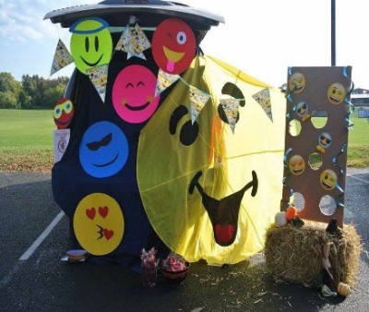

Trunk or Treat

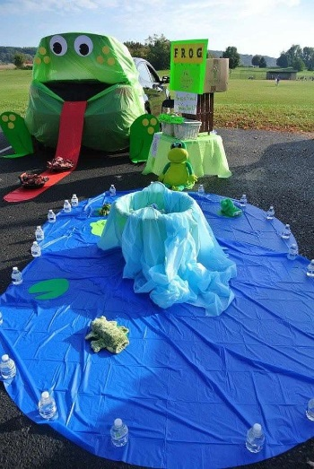

**When:** Sunday October 20th, 2019

From 4 to 6 pm

**Where:** Grace United Methodist Church Parking Lot

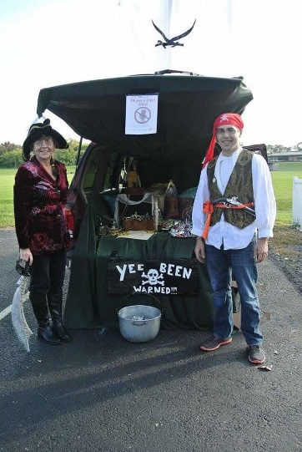

**Please bring an item for the Middletown Food Pantry!!!**

Most needed items: Stuffing Mix, Instant Mashed Potatoes, Can Green Beans, Can Yams, Can Gravy, Cookie Mix, Pasta, Pasta Sauce, other Thanksgiving Themed Can Goods, and Personal Hygiene Products (toothpaste, toothbrush, shampoo, conditioner, deodorant, soap, etc.)

**FREE FOOD GAMES CANDY FUN**

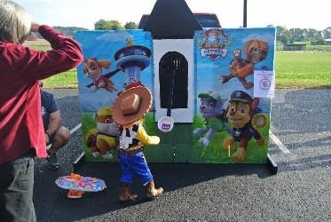 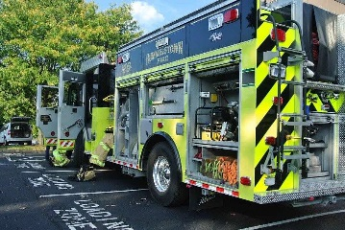  

**THIS EVENT, PROGRAM, or GROUP IS NOT SPONSORED OR ENDORSED BY THE LOWER DAUPHIN SCHOOL DISTRICT.**