

**ULTIMATE SUMMER DAY CAMP – 6/6 – 8/12**

**Full-time, Part-time and Partial Summer**

**Monday through Friday 6:30am – 5:30pm**

**Field trips, swimming, games, crafts,Roller skating, sports and more!**

**Breakfast, lunch and two snacks provided.**

**$25.00 Registration Fee**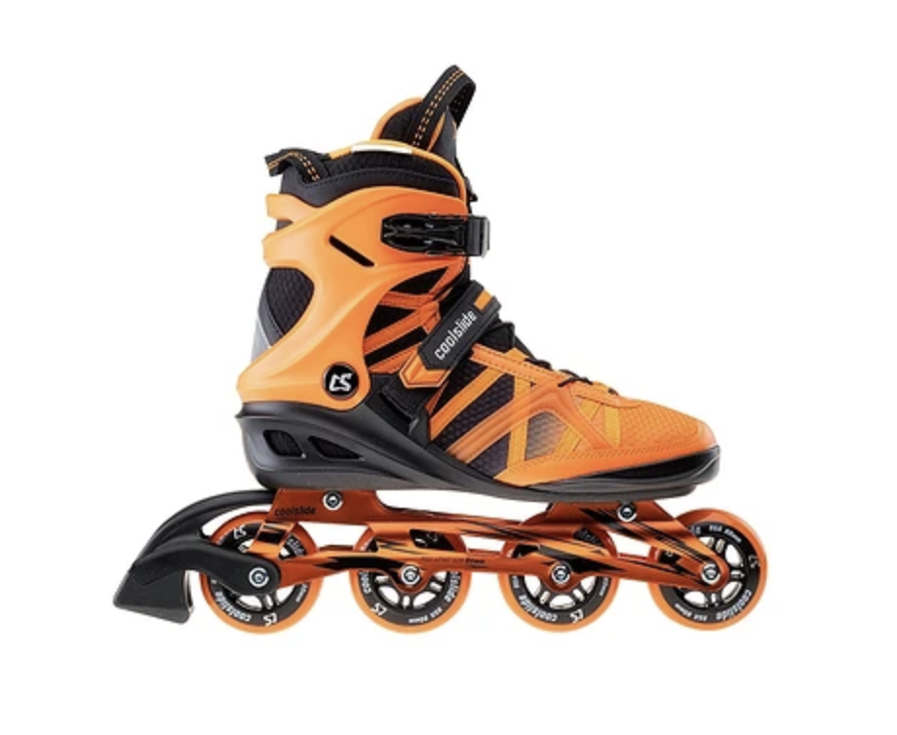

**Open House**

**Tuesday, April 26, 2022**

**6:00pm - 8:00pm**

Kids can enjoy skating as parents meet the counselors and see the facilities.

**For online registration go to:**

[**www.docsfamilyfuncenter.com**](http://www.docsfamilyfuncenter.com) **or call 717.944.7866**





**ULTIMATE SUMMER DAY CAMP – 6/6 – 8/12**

**Full-time, Part-time and Partial Summer**

**Monday through Friday 6:30am – 5:30pm**

**Field trips, swimming, games, crafts,Roller skating, sports and more!**

**Breakfast, lunch and two snacks provided.**

**$25.00 Registration Fee**

**Open House**

**Tuesday, April 26, 2022**

**6:00pm - 8:00pm**

Kids can enjoy skating as parents meet the counselors and see the facilities.

**For online registration go to:**

[**www.docsfamilyfuncenter.com**](http://www.docsfamilyfuncenter.com) **or call 717.944.7866**

