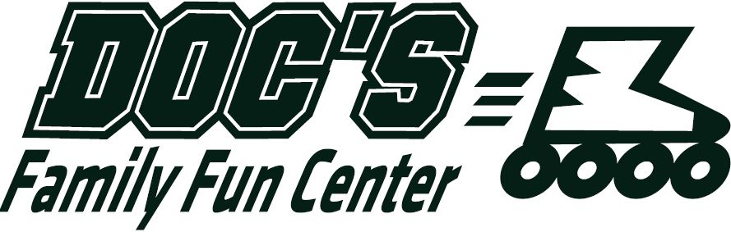
ULTIMATE SUMMER DAY CAMP – 6/1 – 8/16
Full-time, Part-time and Partial Summer
Monday through Friday 6:30am – 5:30pm
Field trips, swimming, games, crafts,
Roller skating, sports and more!
Breakfast, lunch and two snacks provided.
$20.00 Registration Fee

Open House
Sunday, May 5
3:30pm – 5:30pm
Kids can enjoy skating as parents meet the counselors and see the facilities.

For online registration go to
www.docsfamilyfuncenter.com
or call 717.944.7866
This event, program, or group is not sponsored or endorsed by the Lower Dauphin School District

ULTIMATE SUMMER DAY CAMP – 6/10 – 8/16
Full-time, Part-time and Partial Summer
Monday through Friday 6:30am – 5:30pm
Field trips, swimming, games, crafts,
Roller skating, sports and more!
Breakfast, lunch and two snacks provided.
$20.00 Registration Fee
Open House
Sunday, May 5
3:30pm – 5:30pm
Kids can enjoy skating as parents meet the counselors and see the facilities.

For online registration go to
www.docsfamilyfuncenter.com
or call 717.944.7866
This event, program, or group is not sponsored or endorsed by the Lower Dauphin School District.

