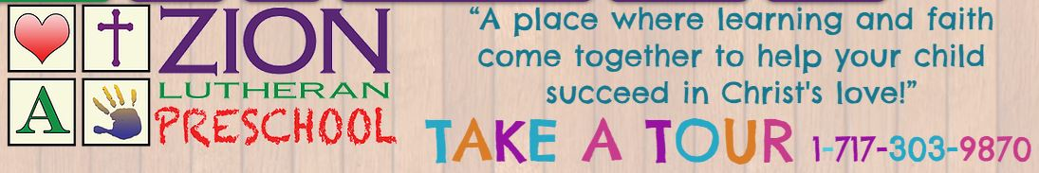**Enrolling 🡪 Fall 2021 @** [**zionlutheranpreschool.org**](https://www.zionlutheranpreschool.org/)

**100 West Main Street Hummelstown**

**COVID Guidelines and Protocols in Place**

**Certified Teachers-CPR + First Aid Trained-Loving**

|  |  |
| --- | --- |
| 3-Year-Old Program | 4-Year-Old/ Pre-K Program |
| **M-W-F**  **9:15 – Noon** | **M-T-W-Th**  **9:15 – 12:15 PM** |

