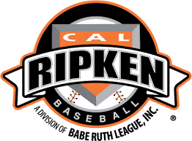

**HBSA, a 2018 Cal Ripken Babe Ruth League Affiliate**

baseball with bat

## 2018 Hummelstown T-Ball, Baseball, and Modified Fastpitch Registration now open!

**When:**  Wednesday January 24th 5-8pm

Saturday January 27th 8:00 AM – 12:00PM

Saturday February 3rd 8:00AM--12:00PM

**Location:** Hummelstown Fire Hall

249 East Main Street

Hummelstown, PA 17036

**Cost:**  $50 Registration for the first child

Plus R&K Sub fundraiser participation OR $30 buyout fee for single player ($50 for family)

*Late registrations will be not be taken after February 9, 2018 and must pay late fee.

Baseball age is determined as of April 30, 2018. Softball age is determined as of January 1, 2018

**Baseball**

T-ball: Ages 5-6

Colt: Ages 7-8

Pony: Ages 9-10

Midget: Ages 11-12

**Modified Fastpitch**

T-ball: Ages 5-6

Modified Ages: 7-14

Costs include Hat or Visor, Jersey and Socks. Players will obtain pants on their own. First time players with HBSA must have a copy of their birth certificate. Any questions please email [HBSABoard@gmail.com](mailto:HBSABoard@gmail.com)

**THIS EVENT, PROGRAM, OR GROUP IS NOT SPONSORED OR**

**ENDORSED BY THE LOWER DAUPHIN SCHOOL DISTRICT**

**Lower Dauphin School District – Policy #707.1**