LONDONDERRY ELEMENTARY PTO’S FAMILY FUN NIGHT

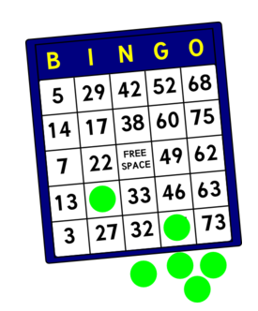

**B I N G O**

**When: Friday January 19, 2018**

**Where: School gym/cafeteria**

TIME: 6:30-7:30pm

This is a free event

sponsored by the PTO for the families of Londonderry students.

.

Come join us for a family fun night of

Bingo & Prizes

Any questions, please contact the Bingo chairperson

Mrs. Annette Trautman

717-944-9462 or [atrautman@ldsd.org](mailto:atrautman@ldsd.org)

THIS EVENT, PROGRAM OR GROUP IS NOT ENDORSED BY THE LOWER DAUPHIN SCHOOL DISTRICT.

LONDONDERRY ELEMENTARY PTO’S FAMILY FUN NIGHT



**B I N G O**

**When: Friday January 19, 2018**

**Where: School gym/cafeteria**

TIME: 6:30-7:30pm

This is a free event

sponsored by the PTO for the families of Londonderry students.

.

Come join us for a family fun night of

Bingo & Prizes

Any questions, please contact the Bingo chairperson

Mrs. Annette Trautman

717-944-9462 or [atrautman@ldsd.org](mailto:atrautman@ldsd.org)

THIS EVENT, PROGRAM OR GROUP IS NOT ENDORSED BY THE LOWER DAUPHIN SCHOOL DISTRICT.