***Robot Arm Design Introduction…Building your own Robot Arm***

1. ***Right now you don’t have a partner,*** you are going to research, find or design your own self-controlled Robot Arm all by yourself. Based on your plan you will then gather up supplies, draw, and label the parts. Your preparation will be “graded” before we talk about partners, only those who are fully prepared with the above will get a partner. You goal is to pick up an upside down plastic cup, without trapping it, lift it 6”off the table and put it down without dropping it. Your arm must release it on its own.

As you are controlling the Robot Arm, your controlling hand needs to be 12+” from the cup, so your overall arm length should be about 30”+-. There is no “right” answer to this problem, so research and creativity is critical to your success and will set you apart from everyone else in your class. <https://www.youtube.com/watch?v=xX6I4ZCLa50>

**Possible research sites:** [**www.youtube.com**](http://www.youtube.com) <https://www.youtube.com/watch?v=phqYMupHn94> <https://www.youtube.com/watch?v=mJOg-Bf581w>

[**www.instructables.com**](http://www.instructables.com)[**https://www.youtube.com/watch?v=oWmxkEXh8ig**](https://www.youtube.com/watch?v=oWmxkEXh8ig) **…No tongs, no silicone hands, no trappers, no lasso’s**

1. **If you are fully prepared for the start of this project, you may pick a partner**, review each other’s design and supplies, then decide on a final plan to make and demonstrate your creation. Part of the teamwork process is sharing ideas and determining which design and who will supply what materials are still needed to complete your plan. You will most likely have enough time to make a 2nd arm for your partner, after the first one passes the test!

**Here is a list of possible supplies to include in your plans:** (I am hoping to not see any more silicone hands!)

* **3”wide Strips and/or pieces of cardboard (I can supply 3” wide wood strips for arms)**
* **Craft Sticks (I have plenty of them right now)**
* **Clothes hangers**
* **Pencils**
* **Straws (I have plenty of them right now)**
* **Rubber bands (I have plenty of them right now)**
* **Synthetic twine or string (I have plenty of it right now)**
* **5/16” x 3” Extension Springs (2 pack)**
* **PVC or Cardboard Tubes**
* **Clothes Pins & Paper Clips (I have plenty of them right now)**
* **Brads or Tiny Nails and eyelet screws (I have plenty of them right now)**
* **Wood or Anything else you may wish to use…**
* **Nuts, bolts & washers (I have some right now)**

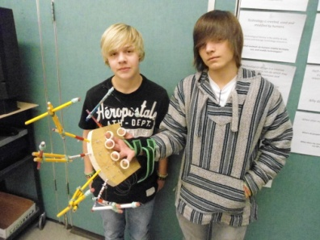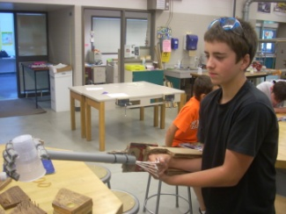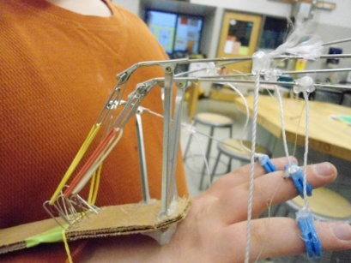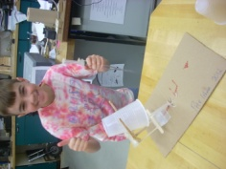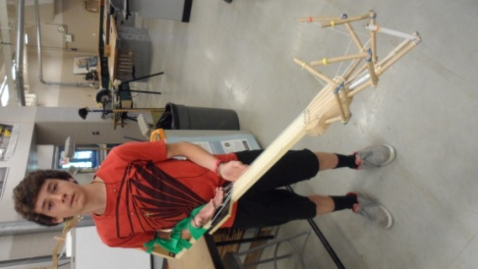 **Turn Paper over to draw & label your design…**

**Your Personal Robot Arm Design drawn & parts labeled:**

**-------------------------------------------------------------------------------------------------------**

1. **Team Plan: Robot Arm drawn & parts labeled: (partner’s name: ___________________________)**
2. **Please place the length of your robot arm, in inches, below your drawing. (you must get it approved before you start building it)**

**What problems did you encounter when trying to make gripping motion and/or pick up the cup?**

**How did you solve them? Be specific.**

**Problem # 1: _____________________________________________________________**

**Solution # 1: _____________________________________________________________**

**Problem #2: _____________________________________________________________**

**Solution # 2: _____________________________________________________________**

**Problem #3: _____________________________________________________________**

**Solution # 3: _____________________________________________________________**