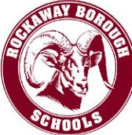

ROCKAWAY BOROUGH SCHOOLS HVAC AND EXHAUST MAINTENANCE PLAN/ FACILITES COVID RESPONSE PLAN

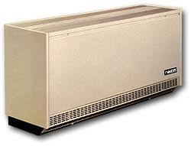

This plan is in addition to our already in place PM schedules through the School Dude facility maintenance software

- All Univents were replaced this summer with and have filters with a MERV rating of no less than 8. There is also anti-bacterial/ anti-viral technology that was added/upgraded to the base model unit.
- All window air conditioner filters will be cleaned monthly, which is more frequent than manufacturer recommendations.
- All exhausts fans were replaced or repaired. An entire new mechanical exhaust system was installed at Lincoln.
- Univents are designed to bring in anywhere from 10% to 20% outside air, with a minimum calculation of 15 CFM per student, which we are currently exceeding if you calculate 15% fresh air over total air flow.
- Victory Electrostatic sprayers will be utilized on high frequency touch points using E22 EPA registered disinfectant.
- In addition, any areas where a suspected covid positive person occupied will be disinfected using the CURIS total room Fogger.
- Maintenance records of all fogger activities will be entered into Schooldude.
- Bathrooms will be cleaned/disinfected twice per day, once at the end of the day, and again midway.
- ALL occupied spaces have been equipped with a true HEPA room air purifier.
- Large occupancy rooms such as the main offices, nurses’ rooms, gyms, and cafeterias are equipped with Hydroxyl air purifiers which actively eliminate bacteria and viruses that are suspended in the air.

