# Local Literacy Plan for W.P. Foster Elementary School/St. Mary Parish

Dr. Angela Steward

Dr. Buffy Fegenbush

June 1, 2023



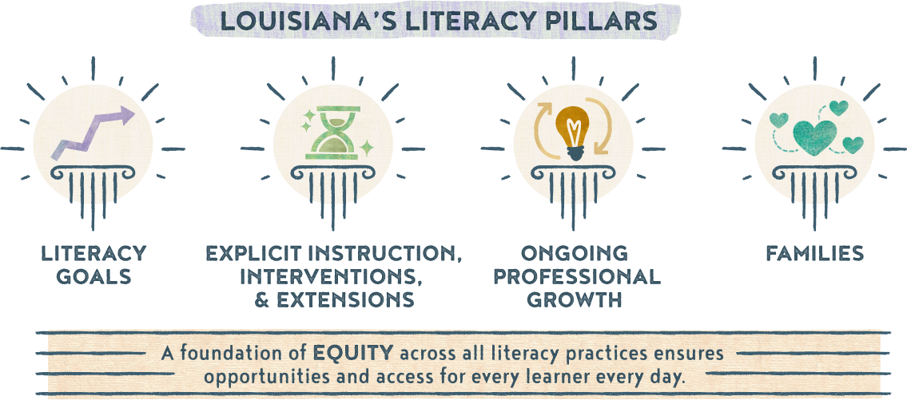

**Section 1a: Literacy Vision and Mission Statement**

* ***Literacy Vision:*** W.P. Foster Elementary believes that strong literacy skills-reading, writing, speaking, and listening are essential in developing responsible, self-motivated learners.
* ***Literacy Mission Statement:*** W.P. Foster Elementary will prepare children to become lifelong readers by empowering communities to provide individualized instruction with measurable results.

**Section 1b: Goals**

* **Goal 1 (Student-Focused):** 50% of students will meet or exceed individual growth goals by May 2024,

based on data collected from the BOY and EOY state approved literacy screener.

* **Goal 2 (Teacher-Focused):**  Teachers will demonstrate effective teaching practices that include meeting

individual needs of students by using student data to effectively drive instruction as evidenced in subgroup literacy growth by 20% from the BOY to the EOY.

* **Goal 3 (Program-Focused):** 53% of our K-3 students will be reading on grade level or show adequate

progress by the end of the school year on literacy screener.

**Section 1c: Literacy Team**

|  |  |
| --- | --- |
| ***Member*** | ***Role*** |
| Dr. Angela Steward | Principal |
| Renee King | Curriculum Facilitator |
| Patrice Mathews | K teacher |
| Vanessa Singleton | 1st grade teacher |
| Billie Adams | 2nd grade teacher |
| Tara Pellerin | 3rd grade teacher |
| Katie Sonnier | K-1 SPED teacher |

**Section 2: Explicit Instruction, Interventions, and Extensions**

**Action Plan**

|  |  |  |  |  |  |
| --- | --- | --- | --- | --- | --- |
|  |  |  |  |  |  |
| *Goal* | *Timeline* | *Action Steps* | *Person(s) Responsible* | *Resources* | *Evidence of Success* |
| 1 | June 1 - June 30 | Review prior year data to establish school system goals. | Data manager and Academics team | Literacy screeners; LEAP scores | Students and subgroups demonstrate growth in year-to-year data. |
|  | May 2023 | **PD** – PK-2 regular ed and special ed teachers will receive Heggerty PD | District staff, CF, teachers |  | Sign-in sheet and agenda  Walk through documentation |
|  | July &  Aug 2023 | **PD** – Engage in literacy professional development | District staff, Admin, CF, literacy coaches, classroom teachers | *[K-5 Small group instructional guidance](http://chrome-extension/efaidnbmnnnibpcajpcglclefindmkaj/https:/www.louisianabelieves.com/docs/default-source/literacy/small-group-instruction---the-how-and-why.pdf?sfvrsn=56706318_4)  *[LDOE provided PD videos](https://www.youtube.com/watch?v=sJuEns00Smg)  *CKLA K-5 coaching  *District embedded PD | Sign-in sheet and agenda  Walk through documentation  Formal classroom observations |
|  | Aug 2023 | **PD** - School instructional staff will participate in BOY student goal setting PD, provided by CF | District staff, Admin, CF, literacy coaches, teachers | District provided PowerPoints | Sign-in sheet and agenda  Documentation of student goal setting |
|  | August 2023  First 30 days  Dec/Jan 23-24  April 2024 | Administer DIBELS BOY, K-5  Administer DIBELS MOY, K-5  Administer DIBELS EOY, K-5 | CF, teachers | State approved literacy screener | Students demonstrate growth towards benchmark goals |
|  | Aug to Dec  &  Dec to April | **Intervention** - PM those students who are performing below grade level at least every 10 days, K-5 | teachers | State approved literacy screener | Student progress towards personal goals measured every 10 days |
|  | August 2023 – May 2024 | **Intervention** - Use 45 minutes of intervention time for small group instruction | Admin, CF, literacy coaches, teachers | LDOE - [FIRE](https://www.louisianabelieves.com/resources/library/literacy-library) & [LIFT kits](https://www.louisianabelieves.com/resources/library/lift-(literacy-interventions-and-foundational-tools)-kit-library)  CKLA | Lesson planning  Walk through documentation  Formal classroom observations |
|  | August 2023 – May 2024 | **Instruction** – Daily implementation of Heggerty phonemic awareness lessons | Teachers |  | Lesson planning  Walk through documentation |
|  | August 2023 – May 2024 | **PD** – Analyze data (benchmarks, PM, assessments, observations) to make needed decisions on small group development and implementation interventions | Admin, CF, literacy coaches, Teachers | State approved literacy screener, weekly assessments, anecdotal notes | Adjusted instruction will be noted as a success in student growth academically |
|  | August 2023 – May 2024 | **Extension** – SPED and regular ed teachers will collaborate based on literacy needs of subgroups | Admin, CF, literacy coaches, teachers |  | Sign-in sheet and agenda  Walk through documentation  Formal classroom observations |
|  | August 2023 – May 2024 | **Instruction** – K-5 will utilize CKLA curriculum as intended | Admin, CF, literacy coaches, teachers | CKLA | Lesson planning  Walk through documentation  Formal classroom observations |
|  | September 2023 – May 2024 | **Instruction** – Implement sound walls in grades K-2 | Teachers | [LDOE Sound Wall](http://chrome-extension/efaidnbmnnnibpcajpcglclefindmkaj/https:/www.louisianabelieves.com/docs/default-source/literacy/sound-wall-instructions-and-template.pdf?sfvrsn=bdb6418_2)  [LDOE Video for Sound Walls](http://chrome-extension/efaidnbmnnnibpcajpcglclefindmkaj/https:/www.louisianabelieves.com/docs/default-source/literacy/sound-wall-instructions-and-template.pdf?sfvrsn=bdb6418_2) | Lesson planning  Walk through documentation  Formal classroom observations |
|  | October 2023 – May 2024 | **Extension** – Provide opportunities for after school tutoring for grades 3-5 | Admin, CF, Teachers | LDOE - [FIRE](https://www.louisianabelieves.com/resources/library/literacy-library) & [LIFT kits](https://www.louisianabelieves.com/resources/library/lift-(literacy-interventions-and-foundational-tools)-kit-library)  CKLA | AST attendance  Lesson plans |

**Section 3: Ongoing Professional Growth**

**Potential PD Planning**

|  |  |  |
| --- | --- | --- |
| July & August  District PD Days | Content Area PD delivered to all teachers | All teachers, CFs, & school admin |
| August | State approved literacy screener - Amplify (DIBELS) | District staff, K-4 ELA teachers, CFs |
| September 2023 – May 2024 | Small group instruction – How to    Engagement Strategies (GLM/PLC)    Classroom Management (GLM/PLC)    MAST (new teacher program)    CKLA (K-5) Coaching days (TBD)    Literacy based PD opportunities    Heggerty PD | K-5 ELA teachers    All content teachers    All content teachers    Newly hired teachers in all areas    K-5 ELA teachers    All K-5 teachers    PK-1 Teachers |
| July 2023 – June 2024 | School Support Institute (SSI) Cohorts | CIR & CLSD school leadership teams |



|  |  |  |  |
| --- | --- | --- | --- |
| ***Month/Date*** | ***Activity*** | ***Accessibility Opportunities*** | ***Community Partners*** |
| August 2023 | Orientation |  |  |
| September 11, 2023 | Books are Fun Kickoff! | Translated materials  Posted on different forums |  |
| September 20, 2023 | Book Study | Varied times  Translated Materials |  |
| September 2023 | Inform families in their native language of student proficiency level in literacy development, including a plan to address any deficiencies. |  |  |
| October 2023 | Share [Grab and Go Activities](https://www.louisianabelieves.com/resources/library/literacy-library/families-literacy-library) with families to support at home learning. | Translated materials  Varied levels of activities |  |
| October 6, 2023 | Literacy Picnic | Translated materials  Varied levels of activities |  |
| October 18, 2023 | Renaissance Lunch | Translated materials |  |
| October 25, 2023 | Book Study | Varied Times  Translated Materials |  |
| November 15, 2023 | Book Study | Varied Times  Translated Materials |  |
| November 2023 | Food Drive (Clubs) | Translated Materials | Emergency Aid  Chez Hope |
| December 2023 | [Evaluate](chrome-extension://efaidnbmnnnibpcajpcglclefindmkaj/https:/www.louisianabelieves.com/docs/default-source/literacy/sample-family-literacy-engagement-survey.pdf?sfvrsn=fbd26718_2) the impact of your current literacy-focused family engagement opportunities and plan. |  |  |
| December 20, 2023 | Book Study | Varied Times  Translated Materials |  |
| December 2023 | Toy Drive (Clubs) | Translated Materials | Area churches  Toys for Tots |
| September 2022-May 2023 | Title I Family engagement Activities (ELA, math, science, social studies nights | Translated materials  Varied levels of activities |  |
| August 2023, January 2024, & May 2024 | Literacy screening results sent home including ways to help at home | Home language |  |
| Ongoing | Parent teacher conference days - Provide info on the support services available and way to help struggling students |  |  |
| January 12, 2024 | Renaissance Breakfast Buffet | Translated materials |  |
| February 29, 2024 | STEM | Translated Materials  Varied levels of activities |  |
| March 22, 2024 | Principal's List Lunch | Translated Materials |  |

**Section 5: Alignment to other Initiatives**

**Initiative Alignment**

|  |  |  |
| --- | --- | --- |
|  |  |  |
| ***Other Programs/Initiatives*** | ***Connecting to Literacy*** | ***Plan to Monitor/Evidence of Success*** |
| Early Childhood Programs | Frogstreet | TS Gold scores – BOY & EOY |
| Title I Plans | Literacy goal and activities in plan | Sign-in sheets |
| 3-5 Grade Tutoring | Providing support | Sign-in sheets, attendance sheets |
| Steve Carter Literacy Tutoring program | Providing literacy support, if available |  |

**Section 6: Communicating the Plan**

**Communication Plan**

|  |  |  |
| --- | --- | --- |
| ***Stakeholder Group*** | ***Plan for Communicating*** | ***Timeline*** |
| District level staff | Plan will be presented at the district team meeting and at site level meetings | November 2023 |
| School faculty | First day faculty meeting will include a review of school literacy plan (add to agenda). | August 2023 |
| Families/Communities | The Literacy Plan will be posted on the school website (link here) for parental feedback and comments. It will also be shared at Open House and Title I family meetings held throughout the year. | August 2023  Ongoing |