Local Literacy Plan

for

Julia B. Maitland/St. Mary Parish

Tonya Hills, Principal

Dr. Buffy Fegenbush, Superintendent of St. Mary Parish

May 25, 2023

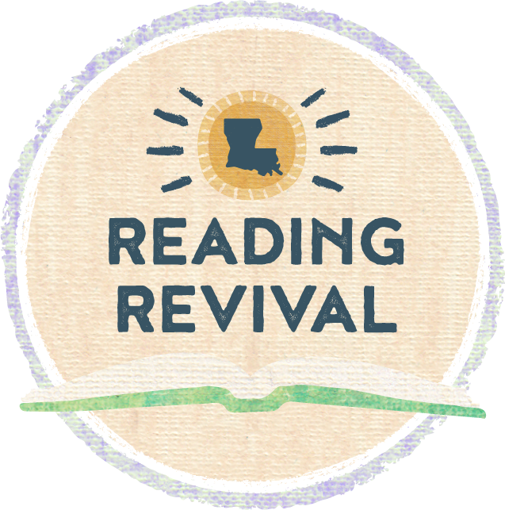

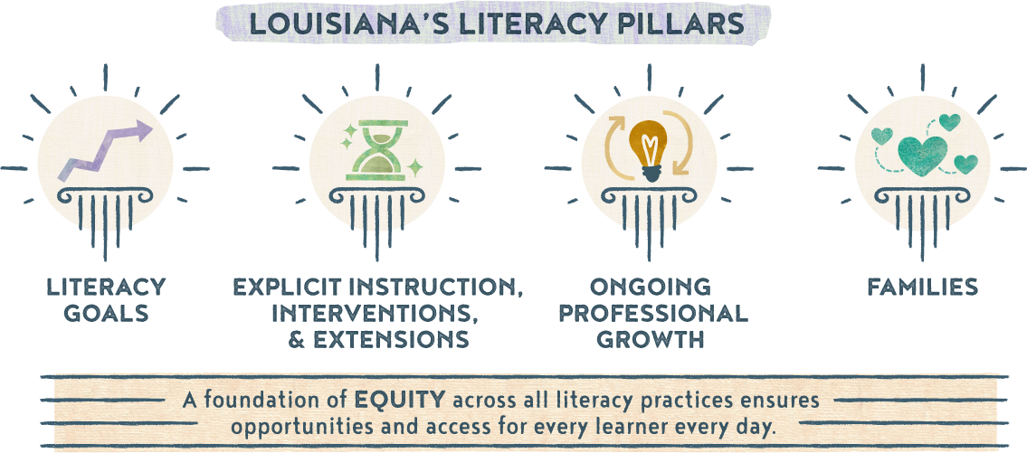

|  |
| --- |
| Section 1a: Literacy Vision and Mission Statement |
| |  |  | | --- | --- | | *Literacy Vision* | Build a strong literacy capacity through language, vocabulary, imagination, and opportunity that will foster new and successful learning in reading, writing, speaking, and listening. | | *Literacy Mission Statement* | Maitland will collaborate with all stakeholders which include teachers, leaders, and parents in literacy decision-making to execute high quality teaching based on curriculum to foster all student needs. | |

|  |
| --- |
| Section 1b: Goals |
| |  |  |  | | --- | --- | --- | | *Goal 1 (Student-Focused)* | 80% of students will meet or exceed individual growth goals by May 2024, based on data collected from the BOY and EOY state approved literacy screener. |  | | *Goal 2 (Teacher-Focused)* | 100% of teachers will participate in professional development to build their capacity as an effective teacher in the area of literacy. |  | | *Goal 3 (Program-Focused)* | 80% of our K-3 students will be reading on grade level or show adequate progress by the end of the school year on literacy screener. |  | |

|  |
| --- |
| Section 1c: Literacy Team |
| |  |  | | --- | --- | | *Member* | *Role* | | Tonya Hills | Principal | | Kendra Thomas | SEL Coach | | Tori Chasson | 1st grade teacher | | Chelsea Marcrum | 2nd grade teacher | | Theresa Rodriquez | 3rd grade teacher | | Chelsea Marceaux | K-2 SPED teacher | | Monica Governale | Librarian |   **Meeting Schedules**   |  |  |  |  | | --- | --- | --- | --- | | *Date* | *Time* | *Location* | *Topic(s)* | | July 2023 | 9:00 a.m. | CF Meeting Room | Review goals of the literacy plan; make needed changes | | Aug 2023 | 8:00 a.m. | Library | Review BOY Data at all levels: school, grade, teacher.  Review student literacy plans & share with current teachers | | Oct 2023 | Cluster Meetings | CF Meeting Room | Review progress monitoring data; make needed changes within small grouping, etc | | Jan 2024 | 8:00 a.m. | Library | Review MOY Data at all levels: school, grade, teacher.  Review student literacy plans, documenting student progress | | Feb 2024 | Cluster Meetings | CF Meeting Room | Review literacy plan, make needed changes based on data | | March 2024 | Cluster Meetings | CF Meeting Room | Discuss professional development needs based on data | | April 2024 | EOY | CF Meeting Room | Review MOY Data at all levels: school, grade, teacher.  Review student literacy plans, documenting student progress. | | May 2024 | Cluster Meetings | CF Meeting Room | Identify 3rd grade students scoring below “basic” achievement level in ELA and are identified as reading below grade level. Create student literacy plan and conduct in person meeting with parents | | May 2024 | 2:00 p.m. | CF Meeting Room | Discuss strengths and weaknesses of the plan  Revisit goals and action plan.  Review current individual literacy plans for the 2024-2025 school year | |

|  |
| --- |
| Section 2: Explicit Instruction, Interventions, and Extensions |
|  |

|  |  |  |  |  |  |  |  |  |  |  |  |  |  |  |  |  |  |  |  |  |  |  |  |  |  |  |  |  |  |  |  |  |  |  |  |  |  |  |  |  |  |  |  |  |  |  |  |  |  |  |  |  |  |  |  |  |  |  |  |  |  |  |  |  |  |  |  |  |  |  |  |  |  |  |  |  |  |  |  |  |  |  |  |  |
| --- | --- | --- | --- | --- | --- | --- | --- | --- | --- | --- | --- | --- | --- | --- | --- | --- | --- | --- | --- | --- | --- | --- | --- | --- | --- | --- | --- | --- | --- | --- | --- | --- | --- | --- | --- | --- | --- | --- | --- | --- | --- | --- | --- | --- | --- | --- | --- | --- | --- | --- | --- | --- | --- | --- | --- | --- | --- | --- | --- | --- | --- | --- | --- | --- | --- | --- | --- | --- | --- | --- | --- | --- | --- | --- | --- | --- | --- | --- | --- | --- | --- | --- | --- | --- |
| **Action Plan**   |  |  |  |  |  |  | | --- | --- | --- | --- | --- | --- | | *Goal* | *Timeline* | *Action Steps* | *Person(s) Responsible* | *Resources* | *Evidence of Success* | | 1 | June 1 - June 30 | Review prior year data to establish school system goals. | Data manager and Academics team | Literacy screeners; LEAP scores | Students and subgroups demonstrate growth in year-to-year data. | | 2 | June 2023 | **PD** – PK-1 regular ed and special ed teachers will receive Heggerty PD | District staff, CF, teachers | Heggerty | Sign-in sheet and agenda  Walk through documentation | | 2 | July &  Aug 2023 | **PD** – Engage in literacy professional development | District staff, Admin, CF, literacy coaches, classroom teachers | *[K-5 Small group instructional guidance](chrome-extension://efaidnbmnnnibpcajpcglclefindmkaj/https:/www.louisianabelieves.com/docs/default-source/literacy/small-group-instruction---the-how-and-why.pdf?sfvrsn=56706318_4)  *[LDOE provided PD videos](https://www.youtube.com/watch?v=sJuEns00Smg)  *CKLA K-5 coaching  *District embedded PD | Sign-in sheet and agenda  Walk through documentation  Formal classroom observations | | 2 | Aug 2023 | **PD** - School instructional staff will participate in BOY student goal setting PD, provided by CF | District staff, Admin, CF, literacy coaches, teachers | District provided PowerPoints | Sign-in sheet and agenda  Documentation of student goal setting | | 3 | August 2023  First 30 days  Dec/Jan 23-24  April 2024 | Administer DIBELS BOY, K-5  Administer DIBELS MOY, K-5  Administer DIBELS EOY, K-5 | CF, Teachers | State approved literacy screener – DIBELS mClass | Students demonstrate growth towards benchmark goals | | 1 | Aug to Dec  &  Dec to April | **Intervention** - PM those students who are performing below grade level at least every 10 days, K-5 | Teachers | State approved literacy screener – DIBELS mClass | Student progress towards personal goals measured every 10 days | | 1 | August 2023 – May 2024 | **Intervention** - Use 45 minutes of intervention time for small group instruction | Admin, CF, literacy coaches, teachers | LDOE - [FIRE](https://www.louisianabelieves.com/resources/library/literacy-library) & [LIFT kits](https://www.louisianabelieves.com/resources/library/lift-(literacy-interventions-and-foundational-tools)-kit-library)  CKLA | Lesson planning  Walk through documentation  Formal classroom observations | | 1 | August 2023 – May 2024 | **Instruction** – Daily implementation of Heggerty phonemic awareness lessons | Teachers | Heggerty curriculum | Lesson planning  Walk through documentation | | 2 | August 2023 – May 2024 | **PD** – Analyze data (benchmarks, PM, assessments, observations) to make needed decisions on small group development and implementation interventions | Admin, CF, literacy coaches, Teachers | State approved literacy screener, weekly assessments, anecdotal notes | Adjusted instruction will be noted as a success in student growth academically | | 1 | August 2023 – May 2024 | **Extension** – SPED and regular ed teachers will collaborate based on literacy needs of subgroups | Admin, CF, literacy coaches, teachers | Data sources | Sign-in sheet and agenda  Walk through documentation  Formal classroom observations | | 1 | August 2023 – May 2024 | **Instruction** – K-5 will utilize CKLA curriculum as intended | Admin, CF, literacy coaches, teachers | CKLA | Lesson planning  Walk through documentation  Formal classroom observations | | 3 | September 2023 – May 2024 | **Instruction** – Implement sound walls in grades K-2 | Teachers | [LDOE Sound Wall](chrome-extension://efaidnbmnnnibpcajpcglclefindmkaj/https:/www.louisianabelieves.com/docs/default-source/literacy/sound-wall-instructions-and-template.pdf?sfvrsn=bdb6418_2)  [LDOE Video for Sound Walls](chrome-extension://efaidnbmnnnibpcajpcglclefindmkaj/https:/www.louisianabelieves.com/docs/default-source/literacy/sound-wall-instructions-and-template.pdf?sfvrsn=bdb6418_2) | Lesson planning  Walk through documentation  Formal classroom observations | | 1 | October 2023 – May 2024 | **Extension** – Provide opportunities for after school tutoring for grades 3-5 | Admin, CF, Teachers | LDOE - [FIRE](https://www.louisianabelieves.com/resources/library/literacy-library) & [LIFT kits](https://www.louisianabelieves.com/resources/library/lift-(literacy-interventions-and-foundational-tools)-kit-library)  CKLA | AST attendance  Lesson plans | |

|  |
| --- |
| Section 3: Ongoing Professional Growth |
| **Potential PD Planning**   |  |  |  | | --- | --- | --- | | **Month/Date**  *(When can PD be scheduled throughout the school year?)* | **Topics**  *(What topics are most needed and should be covered and/or prioritized?)* | **Attendees**  *(Who would benefit most from this PD? Consider also who can redeliver to other teachers/faculty.)* | | July & August District PD days | Content Area PD delivered to all teachers | All teachers, CFs, & school admin | | August | State approved literacy screener – vendor | District staff, K-4 ELA teachers, CFs | | September 2023 – May 2024 | Small group instruction – How to  Engagement Strategies (GLM/PLC)  Classroom Management (GLM/PLC)  MAST (new teacher program)  CKLA (K-5) Coaching days (TBD)  Literacy based PD opportunities  Heggerty PD | K-5 ELA teachers  All content teachers  All content teachers  Newly hired teachers in all areas  K-5 ELA teachers  All K-5 teachers  PK-1 Teachers | | July 2023 – June 2024 | School Support Institute (SSI) Cohorts | CIR & CLSD school leadership teams | | July 2023 – June 2024 | NIET support visits | CIR school leadership teams | |

|  |
| --- |
| Section 4: [Family Engagement Around Literacy](https://www.louisianabelieves.com/resources/library/literacy-library/families-literacy-library) |
| |  |  |  |  | | --- | --- | --- | --- | | *Month/Date* | *Activity* | *Accessibility Opportunities* | *Community Partners* | | August 2023 | Open House | EL translator |  | | August – September 2023 | Positive phone calls home | EL translator  Calling at different times of the day to reach all parents |  | | September 2023 | Inform families in their native language of student proficiency level in literacy development, including a plan to address any deficiencies. | Translated materials  Family friendly letter |  | | September 2023 | Literacy Family Night – center based | Free online resources  Translated materials  EL translator |  | | October 2023 | Share [Grab and Go Activities](https://www.louisianabelieves.com/resources/library/literacy-library/families-literacy-library) with families to support at home learning. | Translated materials  Varied levels of activities |  | | October 2023 | St. Mary Parish visit to create library cards for all students | Library books | St. Mary Parish Library – Morgan City | | November 2023 | Book-a-thon | Beta students | Parents/Families/Community | | November 2023 | Literacy Pumpkins | Children book character decorated pumpkin | Families | | December 2023 | [Evaluate](chrome-extension://efaidnbmnnnibpcajpcglclefindmkaj/https:/www.louisianabelieves.com/docs/default-source/literacy/sample-family-literacy-engagement-survey.pdf?sfvrsn=fbd26718_2) the impact of your current literacy-focused family engagement opportunities and plan. |  |  | | December 2023 | Christmas Festivities | Readings and activities aligned to books | MCHS Key Club | | January | One School, One Book | Calendars  Translated materials  Books provided |  | | March 2023 | Read Across America Week | School-based reading activities daily  Guess Readers | Community Members  Patterson State Bank | | August 2023 to May 2024 | Information, materials, and activities are provided in native language | EL para  Translated materials  iPad with Google translate |  | | August 2023 to May 2023 | Read and Swap | Library books on level  Take Home kits |  | | September 2022-May 2023 | Title I Family engagement Activities (ELA, math, science, social studies nights | EL translator  Translated materials  Varied levels of activities |  | | August 2023, January 2024, & May 2024 | Literacy screening results sent home including ways to help at home | Home language |  | | Ongoing | Parent teacher conference days - Provide info on the support services available and way to help struggling students |  |  | | January - February 2024 | Positive phone calls home | EL translator  Calling at different times of the day to reach all parents |  | |

|  |
| --- |
| Section 5: Alignment to other Initiatives |
| **Initiative Alignment**   |  |  |  | | --- | --- | --- | | *Other Programs/Initiatives* | *Connecting to Literacy* | *Plan to Monitor/Evidence of Success* | | Early Childhood Programs | Frogstreet | TS Gold scores – BOY & EOY | | Title I Plans | Literacy goal and activities in plan | Sign-in sheets | | Kiwanis Club | B.U.G.S. | List of names submitted | | Steve Carter Literacy Tutoring program | Providing literacy support, if available |  | | Amira | EL support intervention program | EL students - Reports | |

|  |
| --- |
| Section 6: Communicating the Plan |
| **Communication Plan**   |  |  |  | | --- | --- | --- | | *Stakeholder Group* | *Plan for Communicating* | *Timeline* | | District level staff | Plan will be presented at the district team meeting and at site level meetings | November 2023 | | School faculty | First day faculty meeting will include a review of school literacy plan. | August 2023 | | Families/Communities | The Literacy Plan will be posted on the school website (link here) and in student handbooks for parental feedback and comments. It will also be shared at Open House and Title I family meetings held throughout the year. | August 2023  Ongoing | | School/Families/Communities | Monthly Newsletters/Calendars - Literacy tips and calendar events will be on the monthly schedule sent home. | August 2023-May 2023 | | Families | BOY, MOY, EOY progress/levels letter will be sent home for families to see progress. | August 2023-May 2023 | |

*Updated A 2022*