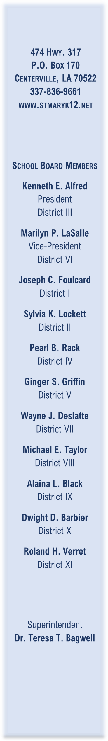
August 2022

LOUISIANA DEPARTMENT OF EDUCATION
COMPLAINT PROCEDURES
FOR
ELEMENTARY AND SECONDARY EDUCATION ACT OF 1965

If the St. Mary Parish School Board Title I Program is not providing services in accordance with state and federal regulations, a parent may file a complaint in accordance with The Louisiana Handbook for School Administrators, Bulletin 741, Section 349, which is available on line at the following website address: http://www.doa.louisiana.gov/osr/lac/28v115/28v115.doc. Parents may also request a copy of this bulletin by calling the Departments toll-free number 1-877-453-2721. This bulletin contains detailed procedures established for resolving complaints filed against the Department of Education or a local education agency pursuant to provisions of the Elementary and Secondary Education Act of 1965, 20 U.S.C. 6301, et. seq. (ESEA).

Summarized from the above handbook, complaints to the Louisiana Department of Education must (1) be in writing and (2) describe a violation of the law or a violation of federal statutes or regulations.

The written complaint must include:

- A statement of the violation of a requirement of a pertinent federal statute or regulation;
- The facts on which the statement is based, including the name of the local education agency;
- A proposed solution of the problem;
- The parent’s signature and contact information;
- Only violations occurring within the past year.

A parent is notified when a complaint has been received by the Department, and complaints will be resolved within 60 days of receiving the complaint, unless the timeline has been extended. The parent will receive a written decision addressing each violation and will also be informed of the right to request that the Secretary of the United States Department of Education review the decision made by the Louisiana Department of Education.

