# Creating a Archivable Homepage School News App

**Note: If possible, these actions should be taken before applying the new template.**

**Goal**: Using a Headlines & Features app, establish an easy way to transfer outdated news items from the school Homepage to an archive page using Shared App and Tagging options.

**Rationale:** Schools often use News postings as evidence for accreditation or judicial purposes. Moving the items to an archive section preserves the evidence and keeps your Homepage clean and relevant.

## Step 1: Add a new Headlines & Features app to your site homepage.

* On your Homepage, drag-and-drop the app labeled “Headlines” into **Section C.** Position it above your current news blog.
* In the upper left corner of the app, change the app name *School New*s (or something similar). Click the green checkmark to save.
* In the same way, change the name of your old blog app to *Old School News* (or something similar).

## Step 2: Create a few Postings in the new Headlines & Features app.

You may recreate a few of your existing news items in the app or create new postings. Make sure to include one posting that is outdated and should be archived from the homepage.

* Open the app’s Edit panel by clicking the gray pencil icon. Select *New* and enter the required information.   
  **Note:** You can click the purple double-arrow before the words *Edit Headline* to expand your work area. (*See image below for location.*)
  1. **Headline Titl***e*. This will become the link to more information, so be concise.
  2. **Accent Image** (*Optional but recommended*): You may select an image that will appear on the left side of any text you enter.
     + If the image does not include words, you can select “This image is Decorative” and skip the *Image Alt Te*xt field.
     + If the image includes words, you must type them into the *Image Alt Text* field.
     + For *Height* and *Width*, be consistent. The district site is currently using a 250-pixel width and allowing the height to automatically adjust to remain proportional.
  3. **Display Duration** (*Optional*)**:** The *Start* and *End Date* fields can be used to control when your news item appears or disappears from public view.
  4. **Current Content Type:** Select the type of information you will include in this posting.
     + *Article*: The Heading Title will link to another page, allowing you to share more extensive text, contact information, and additional (optional) images. The Article option will also provide you with a shareable link for social media sites.
     + *Link*: The app displays the *Link Content* field, into which you paste the URL to which the Headline Title should link. You should include a *Description* for the link.
     + *File*: The app displays the *File Content* field, which allows you to upload a document. The Headline Title becomes the link to the document, which should be checked for accessibility before posting. You should include a *Description* for the document.
  5. **Viewers** *(Advanced; not recommended now)***:** This field can be used if only certain people or groups should view the posting.
  6. **Tags:** This field will be used later to set up your archive process.
  7. **Activate on my page:** Uncheck to hide your work if you are not quite ready to publish.
* Click *Save* to save and/or publish your work. The posting will be activated immediately and will be available to viewers on your website unless you have chosen to deactivate it OR you have set the dates to show only in the future.
* Open the **Options** tab. (*See image below for location*.)
  1. Under *General*, click the checkbox before the words “Show the app name on my page.” Click *Save Options*.
  2. Under *Sharing*, click Assign User. Type your username into the dialog box and click Search. Select your name to move it to the Selected Users area, then click Add. *This step will allow you to display the Headlines and Features app on another website page.*
  3. Click **Save Options**.
* Notice the new **Sort** option. (*See image below*). This app allows you to drag-and-drop your news postings into the desired order instead of relying on the date and time to sort them.
* Remember to click “I’m Done” to avoid the nag reminding you to save.

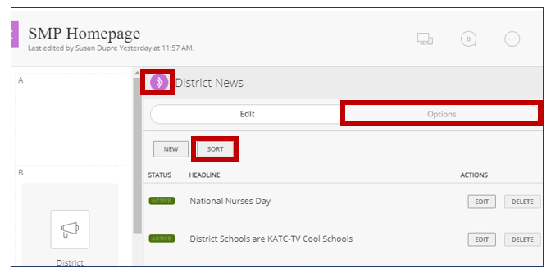

## Step 3: Create an Archive page that displays the Homepage Headlines & Features app.

* Select a Channel and a Section for your old news postings to be displayed. (Suggested Channel: About Our School). If you create a new section called “School News Archive” (or similar) for your archive, it will appear on your Channel Bar drop-down menu.
* In this section, create a new Blank page called “School News Archive” (or similar). Click **Save & Continue.**
* On the new page, scroll down to the area under the *Create New (*Apps*)* section and find *Use Existing.*
  + Select *Headlines & Features* as the app type from the dropdown menu.
  + Find the title of your Homepage app in the list that appears. Drag-and-drop your app to the News Archive page.
  + Open the app by clicking the gray pencil icon. You should see a message in the Edit panel indicating that the app is shared.
  + If you view your website now, you should now see the same posts on the Homepage and on the Archive page.

## Step 4: Create Tags to Move News Items from Homepage to Archive page.

In this step, you will set your Homepage Headlines & Features app to show only “unassigned” (not tagged) posts. At the same time, you will set the shared Headlines & Features app on your News Archive page to show only posts that have been tagged as “archive.”)

* 1. Return to the Headlines & Features app on your Homepage.
  + Open the Edit Headline panel by clicking the gray pencil icon.
  + In the Edit Headline panel, open a posting that should be removed from the Homepage app by clicking its title or clicking *Edit*.
  + Scroll down to the **Tags** section. In the dialog box, type the word **archive**. Click **Save** to close the Edit Headline panel.
* 2. After closing the Edit Headline panel, you will see the Headlines & Features screen again.
  + Reopen the **Options** tab.
  + Open the Tags menu. Select “Unassigned” from the arrow menu and click **Add**. “Unassigned” will now appear in a list beneath the arrow menu box. Click **Save Options**.
  + The app on your Homepage will now only show posts that are untagged (unassigned).
* 3. Return to your New Archive page. Open the shared Headlines & Features app by clicking the green pencil icon.
  + At the bottom of the column containing the “This app is shared” warning, find and open the **Tags** section.
  + Use the arrow menu to select the “archive” tag and click **Add**. The tag “archive” will now appear in a list below the arrow menu. Click **Save Options**.
  + The shared app on the Archive page will now only show posts that are tagged as “archive.”
* **4. Check your work**. The post you tagged as “archive” should have disappeared from your Homepage and is now only appearing on your News Archive page.

## Step 5: Move Homepage Headlines & Features Posts to your News Archive Page in One Step.

Now that you have done the prep work, it is ridiculously easy to archive your posts.

* In the Homepage Headlines & Features app, open the Edit Headlines screen, and select any outdated post by clicking its title OR clicking *Edit*.
* Scroll down to the **Tags** menu. Type “archive” in the dialog box. (The word will appear as you begin typing so that you can select it as your tag.)
* Click **Save**.
* Check your work. The outdated post should disappear from your Homepage and appear only on your News Archive page.

**Note:** If you don’t want a post to be visible in the archive, you can make it *Inactive* by clicking the green *Active* button before or after you archive that item. You have still preserved the evidence, but it is hidden from public view.