# Local Literacy Plan for J.S. Aucoin Elementary

St. Mary Parish School Board

Shantell Toups, Principal

Dr. Buffy Fegenbush, Superintendent

May 2023



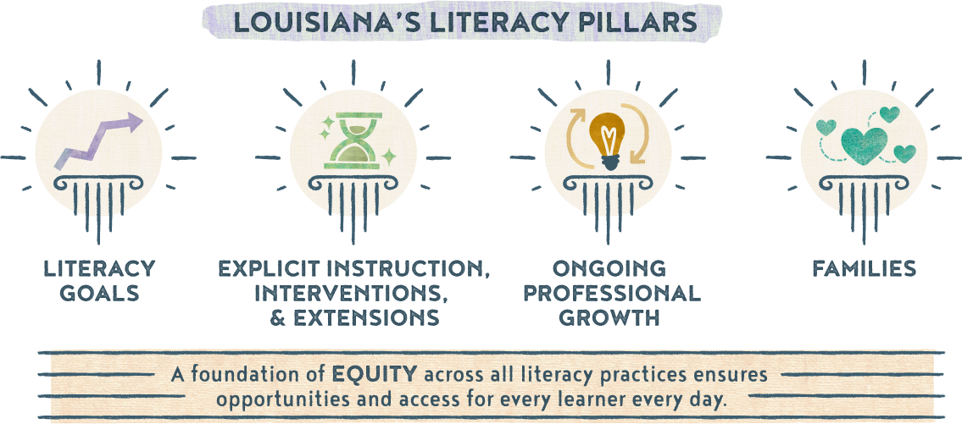

## Section 1a: Literacy Vision and Mission Statement

*Literacy Vision:* It is our vision to promote well-rounded learners with a love for literacy through quality instruction, high expectations, and opportunities for growth.

*Literacy Mission Statement:* J.S. Aucoin Elementary, with the help of teachers, families, and community partners, will ensure students develop reading, writing, speaking, and listening skills to become life-long learners.

## Section 1b: Goals

*Goal 1 (Student-Focused):* 65% of students will meet or exceed individual growth goals by May 2024, based on data collected from BOY and EOY state approved literacy screener.

*Goal 2 (Teacher-Focused):* 100% of ELA teachers will participate in professional development to build their capacity as an effective teacher in the area of literacy.

*Goal 3 (Program-Focused):* To implement a Literacy Program that includes a Tier I curriculum, provides tiered support for students, and is monitored through weekly PLCs and current data.

## Section 1c: Literacy Team

|  |  |
| --- | --- |
| *Member* | *Role* |
| Shantell Toups | Principal |
| Eleanor Dechary | Curriculum Facilitator |
| Sharisse Crochet | ELA teacher (K) |
| Trang Ribardi | ELA teacher (K) |
| Betsy Rhodes | ELA teacher (1) |
| Heather Lorenzo | ELA teacher (2) |
| Erica Chiasson | ELA teacher (3) |
| Kimber Pickens | ELA teacher (4) |
| Jackie Wilson | ELA teacher (5) |
| Kayla Fernandez | SpEd teacher (K-2) |

**Meeting Schedules**

|  |  |  |
| --- | --- | --- |
| *Date & Type of Meeting (Plan Review, Data Analysis, etc.)* | *Frequency of Meetings (Weekly, Monthly, etc.)* | *Topic(s)* |
| July 2023 | TBD | Review goals of the literacy plan; make needed changes |
| Aug 2023 | TBD | Review BOY Data at all levels: school, grade, teacher. Review student literacy plans & share with current teachers |
| Oct 2023 | PLCs | Review progress monitoring data; make needed changes within small grouping, etc. |
| Jan 2024 | MOY | Review MOY Data at all levels: school, grade, teacher. Review student literacy plans, documenting student progress |
| Feb 2024 | PLCs | Review progress monitoring data; make needed changes within small grouping, etc. |
| March 2024 | PLCs | Discuss professional development needs based on data. |
| April 2024 | EOY | Review EOY Data at all levels: school, grade, teacher. Review student literacy plans, documenting student progress. |
| May 2024 | TBD | Identify 3rd grade students scoring below “basic” achievement level in ELA and are identified as reading below grade level. Create student literacy plan and conduct in person meeting with parents. |
| May 2024 | TBD | Discuss strengths and weaknesses of the plan Revisit goals and action plan. Review current individual literacy plans for the 2024- 2025 school year. |

## Section 2: Action Plan (Explicit Instruction, Interventions, and Extensions)

|  |  |  |  |  |  |
| --- | --- | --- | --- | --- | --- |
| *Goal* | *Timeline* | *Action Steps* | *Person(s) Responsible* | *Resources* | *Evidence of Success* |
| 1 | June 1 - June 30 | Review prior year data to establish school system goals. | Data manager and Academics team | Literacy screeners; LEAP scores | Students and subgroups demonstrate growth in year-to-year data. |
| 2 | May/June 2023 | **PD** – PK-2 regular ed and special ed teachers will receive Heggerty PD | District staff, CF, teachers, instructional paras |  | Sign-in sheet and agenda  Walk through documentation |
| 2 | July & August 2023 | **PD** – Engage in literacy professional development | District staff, Admin, CF, teachers, instructional paras | *K-5 Small group instructional guidance *LDOE provided PD videos *CKLA K-5 coaching *District embedded PD mClass/DIBELS | Sign-in sheet and agenda  Walk through documentation  Formal classroom observations |
| 2 | August 2023 | **PD** - School instructional staff will participate in BOY student goal setting PD, provided by CF | District staff, Admin, CF, teachers, instructional paras | District provided PowerPoints | Sign-in sheet and agenda  Documentation of student goal setting |
| 1 | August 2023 First 30 days  Dec/Jan 23-24  April 2024 | Administer DIBELS BOY, K-4 Administer DIBELS MOY, K-4  Administer DIBELS EOY, K-4 | CF, teachers | State approved literacy screener (mCLASS/DIBELS) | Students demonstrate growth towards benchmark goals2 |
| 2 | August 2023-May 2024 | **PD** – Job-embedded professional development in PLCs to support teachers in content delivery, student assessment, and intervention (CKLA, DIBELS, Heggerty) | Admin, CF, teachers, District Program Managers | Observation data  PM data  Weekly assessments | Sign-in sheets  Walk-through observations  Compass Observations  Assessment pieces |
| 1, 3 | Aug 2023 – April 2024 | **Intervention** - PM those students who are performing below grade level at least every 10 days, K-4 | Admin, CF, teachers | State approved literacy screener (mClass/DIBELS) | Student progress towards personal goals measured every 10 days |
| 3 | August 2023 – May 2024 | **Intervention** - Use 45 minutes of intervention time for small group instruction | Admin, CF, teachers, instructional paras | LDOE - FIRE & LIFT kits CKLA mClass/DIBELS | Lesson planning  Walk through documentation  Formal classroom observations |
| 3 | August 2023 – May 2024 | **EL Intervention**: Waterford is a first language reading support program for EL students in grades PK-5. | EL paras  CF | Waterford | Students’ progress toward personal goals.  Waterford reports. |
| 3 | August 2023 – May 2024 | **EL Intervention**: Amira is an AI online reading tutor that helps elementary school-aged children improve reading skills. | EL paras CF | Amira | Student progress reports  Amira reports |
| 3 | August 2023 – May 2024 | **Instruction** – Daily implementation of Heggerty phonemic awareness lessons | Teachers (K-2, SpEd) | Heggerty | Lesson planning  Walk through documentation |
| 2 | August 2023 – May 2024 | **PD** – Analyze data (benchmarks, PM, assessments, observations) to make needed decisions on small group development and implementation interventions | Admin, CF, Teachers | State approved literacy screener (mClass/DIBELS), weekly assessments, anecdotal notes | Adjusted instruction will be noted as a success in student growth academically |
| 1 | August 2023 – May 2024 | **Extension** – SPED and regular ed teachers will collaborate based on literacy needs of subgroups | Admin, CF, teachers |  | Sign-in sheet and agenda  Walk through documentation  Formal classroom observations |
| 2 | August 2023 – May 2024 | **Instruction** – K-4 will utilize CKLA curriculum as intended | Admin, CF, teachers | CKLA | Lesson planning  Walk through documentation  Formal classroom observations |
| 2 | September 2023 – May 2024 | **Instruction** – Implement sound walls in grades K-2 | Teachers (K-2, SpEd) | LDOE Sound Wall  LDOE Video for Sound Wall | Lesson planning Walk through documentation Formal classroom observations |
| 3 | August 2023 – May 2024 | **Extension –** Class/small group assistance will be provided by paraprofessionals | Admin, CF, instructional paras | Intervention materials  Sound walls | Lesson planning  Walk through documentation  Progress monitoring |
| 2 | October 2023-March 2024 | **PD –** Peer observations to observe literacy instruction and strategies | Teachers |  | Peer observation documentation |
| 1 | October 2023 – May 2024 | **Extension** – Provide opportunities for after school tutoring for grades 3-4 | Admin, CF, Teachers | LDOE - FIRE & LIFT kits  CKLA | AST attendance Lesson plans |
| 1 | June 2024 | **Extension –** Provide Summer Literacy Program for those who do not meet benchmark. | Admin, CF, Teachers | State approved curriculum | SLP Attendance  Pre- and Post-assessment data  Lesson plans  Students demonstrate growth towards benchmark goals. |

## Section 3: Ongoing Professional Growth

|  |  |  |
| --- | --- | --- |
| **Month/Date**  *(When can PD be scheduled throughout the school year?)* | **Topics**  *(What topics are most needed and should be covered and/or prioritized?)* | **Attendees**  *(Who would benefit most from this PD? Consider also who can redeliver to other teachers/faculty.)* |
| June, July & August District PD days | Content Area PD delivered to all teachers | All teachers, CFs, instructional paras, & school admin |
| August | State approved literacy screener – mClass/DIBELS | District staff, K-4 ELA teachers, CFs |
| September 2023 – May 2024 | Effective small group instruction  Engagement Strategies  Classroom Management  Literacy based PD opportunities  Heggerty PD | K-4 ELA teachers, SpEd teacher  All content teachers  All content teachers  All K-4 teachers, SpEd teacher  PK-2 & SpEd teachers |
| August 2023 – May 2024 | School-wide strategies (reading, writing, vocabulary) | All content teachers |
| October 2023 – March 2024 | Peer observations (focus is literacy instruction and strategies) | All content teachers |

## Section 4: Family Engagement Around Literacy

|  |  |  |  |
| --- | --- | --- | --- |
| *Month/Date* | *Activity* | *Accessibility Opportunities* | *Community Partners* |
| August 2023 | Open House | Parents meet with faculty and admin to discuss important topics for a successful school year. |  |
| August 2023 – May 2024 | Positive parent contact home | EL translator  Calling at different times of the day to reach all parents |  |
| August 2023 – May 2024 | Share Grab and Go Activities and JSA ‘Borrow Bags’ with families to support at home learning, as needed. | Translated materials  Varied levels of activities |  |
| August 2023 – May 2024 | Information, materials, and activities are provided in native language | EL para  Translated materials |  |
| September 2023 | Inform families in their native language of student proficiency level in literacy development, including a plan to address any deficiencies. | DIBELS letters in English and Spanish when applicable |  |
| September 2023 | Family Literacy Night | Varied levels of activities  EL translator  Translated materials |  |
| February 2024 & April 2024 | LEAP and ELPT Parent Workshop | EL translator  Translated materials |  |
| March 2024 | Literacy Week Activities | Varied levels of activities |  |
| August 2023, January 2024, & May 2024 | Literacy screening results sent home including ways to help at home | EL translator  Translated materials |  |
| Ongoing | Parent teacher conference days - Provide info on the support services available and way to help struggling students | EL translator |  |

## Section 5: Alignment to other Initiatives

|  |  |  |
| --- | --- | --- |
| *Other Programs/Initiatives* | *Connecting to Literacy* | *Plan to Monitor/Evidence of Success* |
| Early Childhood Programs | Frogstreet/Heggerty | TS Gold scores – BOY & EOY |
| Title I Plans | Literacy goal and activities in plan | Sign-in sheets |
| Kiwanis Club | Bugs (Bringing Up Grades) Awards | List of names submitted |
| Accelerated Reader | Literacy incentive | Student participation |
| Steve Carter Literacy Tutoring program | Providing literacy support, if available |  |
| Coast Guard | Providing literacy support | Sign-in sheets |

## Section 6: Communicating the Plan

|  |  |  |
| --- | --- | --- |
| *Stakeholder Group* | *Plan for Communicating* | *Timeline* |
| District level staff | Plan will be presented at the district team meeting and at site level meetings | November 2023 |
| School faculty | First day faculty meeting will include a review of school literacy plan (add to agenda). | August 2023 |
| Families/Communities | The Literacy Plan will be posted on the school website (link here) for parental feedback and comments. It will also be shared at Open House and Title I family meetings held throughout the year. | August 2023  Ongoing |

Review the [School System Literacy Roadmap](https://www.louisianabelieves.com/docs/default-source/literacy/school-system-literacy-roadmap.pdf?sfvrsn=20a06718_4) for recommended timelines for action steps to promote literacy.

For additional guidance and resources, visit the [Louisiana Literacy’s webpage](https://www.louisianabelieves.com/academics/louisiana-literacy), [Literacy Library](https://www.louisianabelieves.com/resources/library/literacy-library), or email [louisianaliteracy@la.gov](mailto:louisianaliteracy@la.gov). *Updated A 2022*