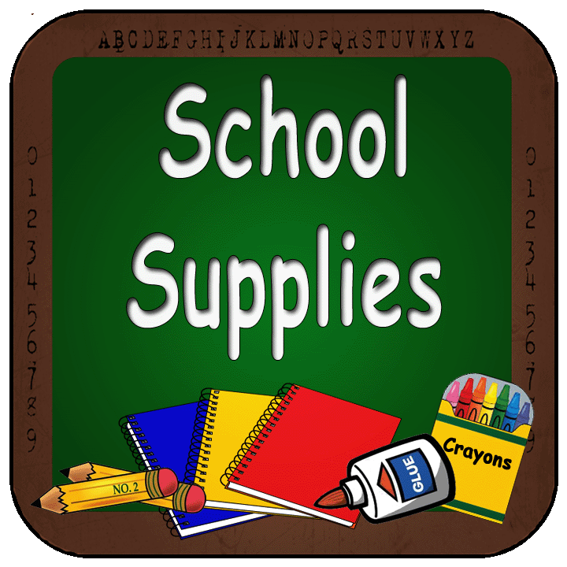

Welcome to ^{3rd} Grade
*To make sure that the beginning of the school year runs smoothly, please have these supplies within the first week of school*

*Please make sure all folders and notebooks are labeled with your child’s name*

3rd GRADE SUPPLY LIST:

- STURDY backpack
- 4 HARD plastic folders with pockets on the bottom
(1 red, 1 blue, 1 yellow, & 1 green)
- 4 MARBLE notebooks-WIDE RULED ONLY
- (1 red, 1 blue, 1 yellow, 1 blue)
- 3 boxes of Crayola crayons (24 count only)
- 3 yellow highlighters
- 4 boxes of 24 pre-sharpened Ticonderoga pencils
- 1 pair of Fiskar scissors
- 1 small bottle of Elmers glue
- 15 Elmers glue sticks
- 1 hard covered standard pencil case (9x6)
- 2 packs of post-it notes (not lined)
- 1 clipboard
- 1 GOOD pair of earbuds or headphones
- 4 packs of plain white index cards
- 1 pack of baby wipes

