**Middle Country Community Resource Links**

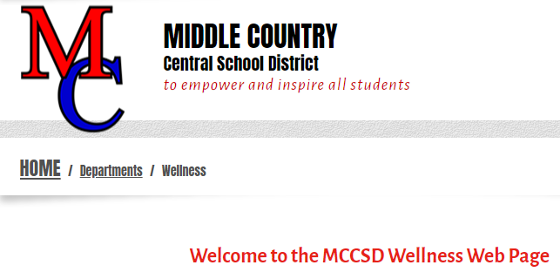[**https://www.mccsd.net/wellness**](https://www.mccsd.net/wellness)

**Summer Feeding & Meal Support**

|  |  |  |
| --- | --- | --- |
| |  | | --- | | **Find Summer Meals:**  **Text "Food" to 304-304**  **Visit SummerMealsNY.org**  **Call 211 or 311 (in NYC) or 1-866-3-HUNGRY** | |  | |

**Food Pantries**

Days & Hours of Operation

* Centereach Assumption of BVM Outreach20 Chestnut St. Centereach, NY 11720631-585-8760, Tues/Weds/Fri 11am-1pm *by appointment only
* Lighthouse Mission 2150 Middle Country Rd. Centereach, NY 11720631-758-7584, Friday 12pm-1pm
* Our Savior Lutheran Church140 Mark Tree Rd. Centereach, NY 11720631-588-2757, Mon.-Thurs. 3pm-5pm

 <https://www.licares.org/find-food/>

<https://www.licares.org/>

<https://www.licares.org/what-we-do/feed-long-island/>

<https://www.licares.org/what-we-do/feed-long-island/first-stop-food-pantries/>

 <https://www.islandharvest.org/find-help/find-a-food-pantry/>

 <https://hungersolutionsny.org/find-food-help/>

<https://hungersolutionsny.org/federal-nutrition-programs/pebt/>

**English, Español and Other Languages SNAP prescreening tool:**

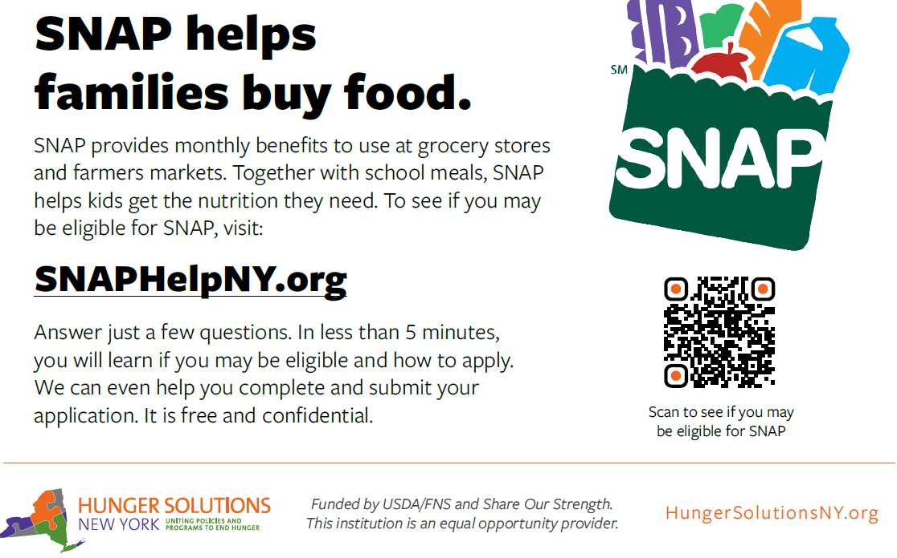

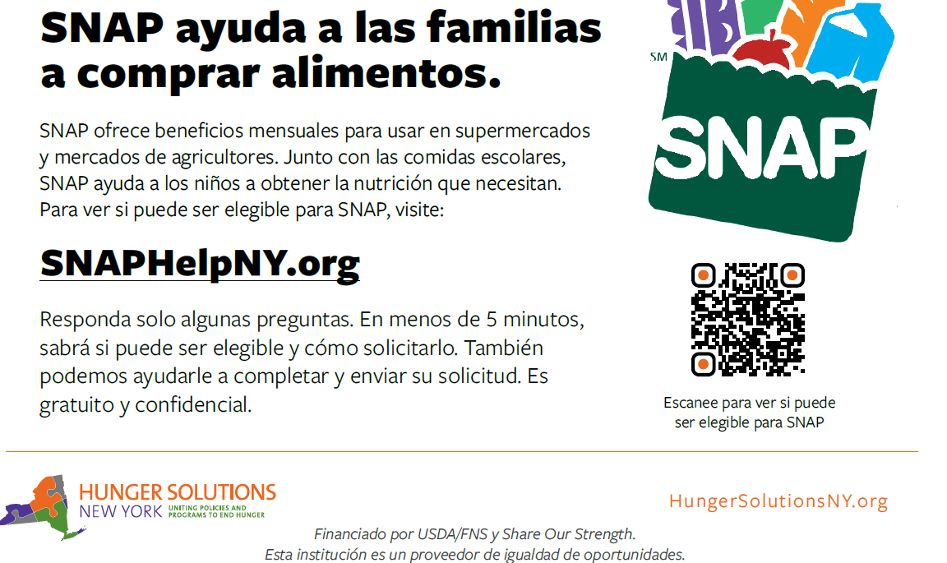

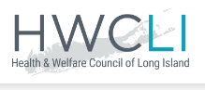 <https://hwcli.com/news/>

[https://hwcli.com/work-we-do/direct-services](https://hwcli.com/work-we-do/direct-services/)/

<https://hwcli.com/work-we-do/coalition-grassroots-organizing/emergency-food-shelter-program/>

<https://hwcli.com/work-we-do/direct-services/snap/>

<https://hwcli.com/work-we-do/direct-services/emergency-rental-assistance-program-erap/>

 **https://otda.ny.gov/programs**

NYS OTDA – Office of Temporary Disability Assistance: **1-800-342-3009**

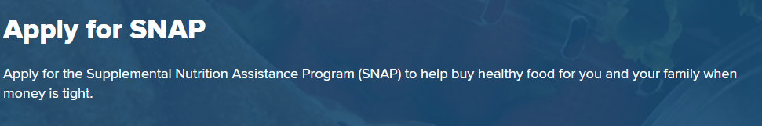

**https://www.ny.gov/services/apply-snap**

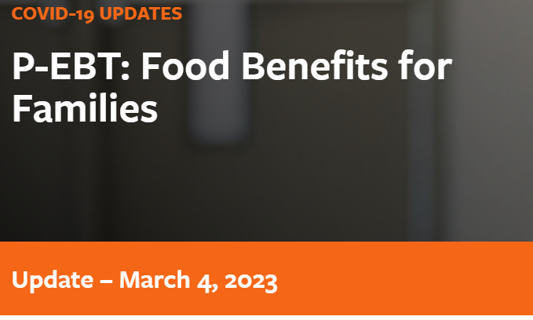 **Pandemic Electronic Benefit Transfer (P-EBT) Food Benefits**

If you have further questions regarding your child's eligibility, please contact the P-EBT Helpline at **1-833-452-0096, NYS P-EBT Customer Service 1-888-328-6399** or visit: [P-EBT Information Form](https://otda.ny.gov/PEBT-Info) to submit your question in writing.