Middle Country Central School District
Dept of Health, Physical Education & Athletics
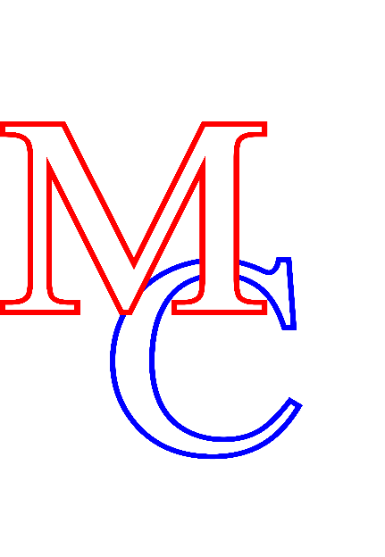
145 Marshall Drive • Selden, NY 11784
631-285-8650 • 631-285-8151 (fax) • www.mccsd.net

Roberta A. Gerold, Ed.D., Superintendent of Schools
Francine McMahon, Deputy Superintendent for Instruction
Herbert B. Chessler, Assistant Superintendent for Business
James G. Donovan, Assistant Superintendent for Human Resources
Joseph Mercado, Director of Health, Physical Education & Athletics

NYSCSH PROVIDER ATTESTATION & PARENT PERMISSIONS FOR INDEPENDENT MEDICATION CARRY AND USE
Directions for the Health Care Provider: This form may be used as an addendum to a medication order which does not contain the required diagnosis and attestation for a student to independently carry and use their medication as required by NYS law. A provider order and parent/guardian permission are needed in order for a student to carry and use medications that require rapid administration to prevent negative health outcomes. These medications should be identified by checking the appropriate boxes below.
Student Name: ____________________________________ DOB: ____________________
Health Care Provider Permission for Independent Use and Carry
I attest that this student has demonstrated to me that he or she can self-administer the medication(s) listed below safely and effectively, and may carry and use this medication (with a delivery device if needed) independently at any school/school sponsored activity. Staff intervention and support is needed only during an emergency. This order applies to the medications checked below:
This student is diagnosed with:
Allergy and requires Epinephrine Auto-injector
Asthma or respiratory condition and requires Inhaled Respiratory Rescue Medication
Diabetes and requires Insulin/Glucagon/Diabetes Supplies
_______________________which requires rapid administration of _________________
(State Diagnosis) (Medication Name)
Physician Signature: ___________________ Date: __________________ Office Stamp:

Parent/Guardian Permission for Independent Use and Carry
I agree that my child can use their medication effectively and may carry and use this medication independently at any school/school sponsored activity. Staff intervention and support is needed only during an emergency.
Signature: __________________________________ Date: __________________
Please return to School Nurse:
School Nurse: Mrs. Cleary, RN and Mrs. Powell, RN |  | School: Dawnwood Middle School
Phone #: 631-285-8220 | Fax: 631-285-8262 | Email:

