2016-2017 Physical Education Study Guide

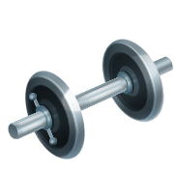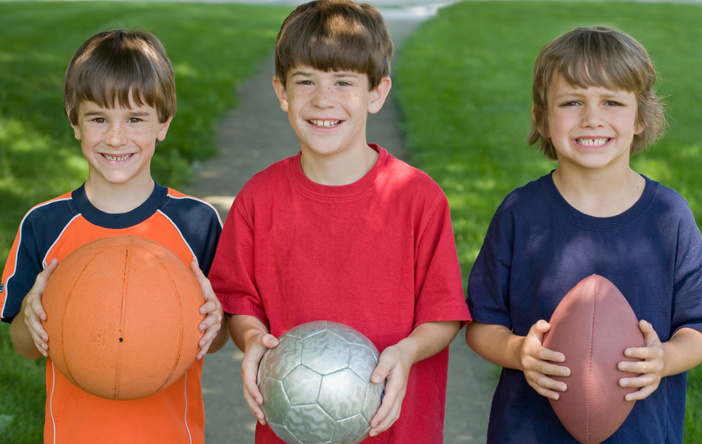

Middle School Final Exam
Study guide
Soccer Skills
Dribbling, Trapping, Passing, Shooting, Defense, Throw In
Inside of the foot dribble
Gentle tap
Contact on inside of the foot
Keep ball close to you and your head up
Trapping: stopping the ball
Sole of the foot trap
Heel low
Contact ball low
Trap ball between ground and bottom of foot
Passing
Inside of the foot pass
Non kicking foot placed beside ball
Toes pointed to target
Contact ball with the inside of the foot
Shooting
Instep kick
Kicking foot beside ball
Contact the ball with the shoelaces never the toe
Defense
Front Tackle
Challenging foot turned out at a right angle
Contact ball at the same time as opponent
Push through the ball like a push pass
Throw In
Two hands on ball
Ball is placed above head
Step with the opposite foot
Both feet stay on ground as throw is made
Goaltending
Thumbs together to form a W
Elbows bent
Soft hands while receiving ball and bring it into the body
Facts about soccer
1. Throughout the world soccer is called “football”.
2. The World cup is played every 4 years.
3. Two famous soccer players are David Beckham and Mia Hamm.

Football (American)
Throwing
Receiving
Running Strategy
Defense
Throwing
Side/Shoulder to Target
C grip on back of ball
Follow through motion across body
Receiving
Above the waist
Eye contact
Show diamond with hands
Below the waist
Eye contact
Pinkies together
Thumbs out
*Tuck away into body after receiving ball
Running Strategy
Cut left
Cut right
Button hook
Slant
Post
Defense
Man to man: Force opponent outward and stick to them like glue
Zone: Play the area and funnel toward the center
Line of Scrimmage: The imaginary line between offense and defense

Modified Class Rules:
- We use a throw off instead of a kick off to start the game and after a touchdown is scored.
- A player should never tie their flag around their waist. They should always clip it.
- A team has 4 chances or downs to complete a first down.

European Handball
Modified Class Rules of European Handball
Rules:
1. Person with ball may only take three steps.
2. Goalie crease:
Only the goalie may be in the goalie box.

3. There is no physical contact.
The ball may not be taken out of any player’s hand.
4. In Class the Game starts off with a jump ball.
5. A goal is worth one point.
6. A goalie can use any part of their body to try to stop the ball.

Passing: There is no limit on the amount of passes and you can pass in any direction.
European handball is an Olympic sport.

The court is similar to a basketball court

BASKETBALL
Skills
Dribbling
Passing
Shooting
Lay-up
Defense
Dribbling
Push ball with pads of fingers
Ball should bounce waist level high
Ball should be kept to side of body
Head should be up

Passing: always make sure receiver is looking at you before you pass

Chest pass
Step to target
Leaves players chest
Elbows out
Finishes are receiver’s chest

Bounce Pass
Step to target
Leaves passers chest
Bounces in a check mark pathway 3/4 of a way to receiver

Over the head pass
Ball is brought over the head with two hands
Passer aims to target
Feet remain on ground
Shooting
Set Shot: Remember BEEF
Balance Feet should be shoulder width apart and balanced
Eyes should be focused on the basket
Elbow should be aligned with basket
Follow through shooting hand should follow through like it is waving “bye-bye” to the ball

Lay-up
Approach the basket from the sides of the basket
Take two steps and a hop
Bring ball up with shooting hand
Lay the ball on the back board

Defense
Athletic stance be on the balls of your feet
Use a drop step to stay with offense
Keep eyes focused on the center of opponent’s body

Things to remember about basketball
There are five players on the court for each team.
Each basket inside the three point line is worth two points.
A foul shot is worth one point.
You can not dribble with two hands on the ball.
You can not walk with ball you must pivot.
You can not stop dribbling and begin to dribble again. You must shoot, pass, or call a time out.

Basic Principles of Fitness

A healthy lifestyle consists of exercising 3-4 times a week

Students will do 2 to 3 sets of 10 to 15 reps.
Students should inhale and exhale throughout entire exercise.
Students will do an exercise with full range of motion.
Students who do cardiovascular exercises strengthen their heart and lungs.

Fitness Exercises and Muscles:

Legs: Quadriceps, (largest muscle in the leg), hamstring, gastrocnemius (calf)
Leg extension
Leg curl
Leg press
Toe raises

Shoulders: Deltoid
Military press (Bench Press)
Dumb bell press
Lateral raises
Frontal raises
Shrugs

Back: Trapezius, Latissimus Dorsi Cardio Vascular Endurance
Lat pull down Treadmill (running/ walking)
Seated Row Bike & Elliptical
Pull ups Rowing Machines

Chest: Pectoralis Major and Pectoralis Minor
Bench press
Fly machine or dumb bell
Pec- dec
Push ups
Continued Fitness:
Arms: Triceps(3 muscles),
Biceps (2 muscles) Abdominals and Obliques
Dumb bell curl Leg Raises
Triceps pushdown Abs Machine
Triceps extension Crunches/Curl ups
Dips

Volleyball Skills

Forearm Pass ***CAN NOT HIT BALL 2 TIMES IN A ROW
Set
Underhand serve
Overhead serve
Top spin serve
Floater Serve

Forearm Pass Set
Move to the ball Arrive before the ball
Face target bend knees Big hands over head
Arms in a flat platform Extend arms and legs
Arms out in front of body Follow through to ceiling
Never bend elbows
Ball contacts forearms

Serving
1. Toss ball high and out in front. Toss should line up with the front foot. Bring arm back in a motion like a bow and arrow shoot.
2. Contact with the hard bottom part of hand
Topspin the ball by snapping wrist and having a good follow through
Float the ball by stopping your hand after contact.
Serving comes from the back right of court
3. Six players per side on court.
4. Three hits per side to get the ball over the net.
5. Rotating in volleyball is clockwise. Your team rotates when they win the serve back.
6. A ball that hits the line is in bounds.
7. Types of illegal hits are called carrying, palming, and throwing.

Badminton Skills
Dated back to Ancient China
Gripping racket
-v grip
Underhand serve
-take place below the waist
-birdie should go diagonal over the net
Overhead clear shot
-should land in the back of the opposite court
Smash
-forceful shot like a spike in volleyball
Back hand
-arm goes across the body
Drop shot
-a soft shot that land’s just over the net.
Serve
Must be an underhand shot and go diagonal over the net

Players OR racket may not touch the net.
Points are only worth one at a time
One hit per side
A birdie is also called a shuttle

Tennis
Skills:
Ground stroke: hitting the ball low to high. Using a “handshake” grip on racket.

Serve: Must be over head, the toss is the most important part of serve. Hitting ball at highest point of toss, toss should be out in front of hitting arm.

Forehand: Player pivots body so that the shoulder of the non racket arm faces the net. The player then swings the racket forward to meet the ball.

Backhand: Player turns so that the shoulder of the racket arm faces the net before bringing the racket forward and across the body to meet the ball.

Drop Shot: A lightly hit, spinning return that drops softly over the net, forcing the opponent to approach the net.

Double Fault: When both serve attempts fail and the opponent wins the point.

Base line: The line on either end of the court representing the outer limits of the length of the court.

Fault: Called if the ball is served into the net, or makes contact with net before hitting your opponents’ court outside the service box or before exiting the court completely.

Love: Zero points

Smash: Powerful shot often used to return a lob that has not been hit high or deep enough. The shot is hit in a similar manner to the serve.

Scoring in Tennis:

No Points= Love
First point= 15
Second point= 30
Third point = 40
Fourth point = Game
Deuce= each side has 3 points or 40 all.

A Set in tennis is the player who wins 6 games and is ahead by 2 games. Exceptions are when the games are tied at 6-6 each, and players play a 12 point tie breaker. The set is scored 7-6 for the winner.

A Match in tennis is 2 out of 3 set or 4 of 5 sets.

A ball hitting a line in tennis is considered in play.

No player can make contact with the net (not even their racket can touch the net)

In doubles play one player serves out the entire “game”.
Each player will get a chance to serve a game or two during a set.

The serve must be served overhead and diagonally across to their opponents’ service box. You have 2 chances to get the serve into your opponents’ service box.
The ball may only bounce once before contact is made. Hitting a ball without bouncing is called a “volley”.

Field Hockey

Rules:
- You may only use one side of the stick when dribbling the ball.
- You CANNOT let the ball touch you feet.
- Only the goalie can use their hands but they may not grip the ball
- The stick can only go waist level. If the stick is above the waist when a player
Is shooting it is a “high sticking” violation.
- A goal is worth 1 point.
- To be in a good defensive position a player must start off in a athletic stance.

Dribble:
There are three dribbles in field hockey
- Loose dribble : The ball comes off the stick when dribbling
- Control or tight dribble: the ball stays on the stick the entire time
- Reverse dribble: The stick is rotated to the non-stick side to control and dribble the ball.

Field Hockey is played by both men and women.
Field hockey is an Olympic sport.

