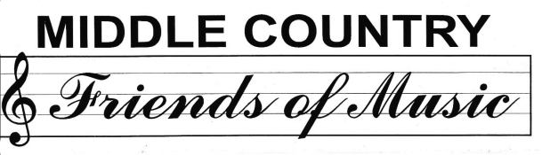

Dr. Jo Ann Wood – President
Jennifer Matteo – Co Vice President
Tanya Bayles – Co Vice President
Elaine Vogel – Secretary
Patti Delgado – Treasurer
Debbie Toto- Co Historian
Gina Fecile- Co Historian
Dr. Diana Cook – Director of Music, Fine Arts & Community Media Relations

The Middle Country Friends of Music was founded in 1981. Our board is made up of parent volunteers who work in conjunction with the Music Department to promote the talents of our children. The Friends of Music co-sponsor the annual POPS concert along with other fundraising ventures which allow us to offer our music students the following:
Elementary Schools- Student of the Trimester Awards, 5th grade Friends of Music awards, and All District Concert T Shirts to over 300 participants
Middle Schools- Six 8th grade Friends of Music monetary awards (2 for each ensemble at each middle school) and an annual T-Shirt design contest prize
High Schools- 18 monetary scholarships (3 in each ensemble at each high school)
Additionally, the Friends of Music awards $3000 in Mini Grants to teachers who apply, for program enhancement and student enrichment. We also advocate for the preservation of music and music related programs in our district. Contact us at middlecountryfriendsofmusic@gmail.com and please “like” us on Facebook.

OVER 30 YEARS SUPPORTING MUSIC IN THE MIDDLE COUNTRY COMMUNITY!

MIDDLE COUNTRY FRIENDS OF MUSIC 2015-2016 MEMBERSHIP FORM

DATE________________ $5.00 PER FAMILY CASH__________ CHECK________

MAKE CHECKS PAYABLE TO: MCCSD FRIENDS OF MUSIC
SUBMIT TO MUSIC TEACHER OR MAIL FORM TO: PO BOX 237 CENTEREACH NY 11720

NEW MEMBER________ RENEWAL MEMBERSHIP______________

Parent First/Last Name______________________________ Phone #_________________________
Email address:______________________________________________________________________
Address: __________________________________________________________________________

First/Last Name of Child Band Orchestra Chorus School Grade
_________________________________ _______ ________ ______ _________ _______
_________________________________ _______ ________ ______ _________ _______
_________________________________ _______ ________ ______ _________ _______
_________________________________ _______ ________ ______ _________ _______

