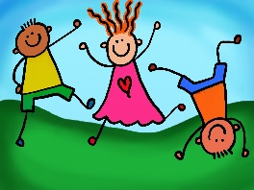

Welcome to UPK!

Here is a supply list that will be helpful for our year together. Please make sure all supplies are clearly labeled with your child’s name. Please bring all supplies to school at our UPK Orientation in August. (date to be announced)

~Mrs. Bouck and Mrs. Stey

**Strongly Suggested Items:**

1 full sized backpack to fit folders and artwork (no wheels)

1 change of clothes in a clear zip lock bag, labeled with your child’s name (This includes shirt, pants, socks, and underwear. Items to be replaced as needed)

2 packages of hand wipes

4 (4oz) containers of playdoh

1 smock (with long sleeves)

1 box zip lock gallon bags

1 box zip lock sandwich baggies

1 package of plain (uncoated) white paper plates (small or large)

1 small child sized blanket for rest time (no sleeping bags please)

6 purple glue sticks **(Stey only)**

1 collage of family photos (This will be displayed all year for your child to look at when they are missing you. Please keep size to 12”x18” or less)

**Optional Items for the class to share:**

Crayon “rocks” (available on amazon)

sidewalk chalk

bottle of bubbles