Welcome to 6th grade!

Supply List for 2024-2025 School Year

Each teacher will have their own homeroom for ELA. Mrs. Dabroski will be your Social Studies teacher, Ms. Figurski will teach Science, and Mrs. Wadsworth teaches Math.

General Supplies:

* Pencils
* Pens (only blue or black ink)
* Handheld sharpener
* Pencil case/pouch
* One pack of 4-Expo markers
* An accordion file folder with at least 4 sections 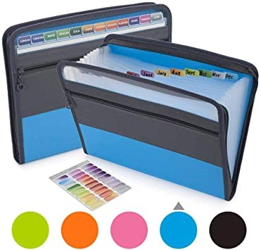
* Colored pencils or crayons
* 1 pack of Glue Sticks
* Scissors
* 1 Notebook (spiral or composition) for Math
* 1 three subject Notebook to be shared with Social Studies, Science & ELA
* Ear buds/headphones (please no Bluetooth) and a case or zip-lock bag to put them in. Please label with name.
* Highlighter
* Clorox wipes