**4TH GRADE School Supply List for the 2024-2025 School Year:**

**(Teachers: Mrs. Deagostino, Mrs. Lynch, and Mrs. Siegel)**

* 4 packages of #2 pencils
* 3 handheld **sharpeners** with tops
* 4 erasers
* 1 box of 12-16 count crayons*
* 1 box of Crayola washable markers
* 1 box of colored pencils*
* 3 packs of glue sticks*
* 1 pair of Fiskar scissors
* 4 fine tip Expo dry erase markers (NOT extra fine)
* 4 composition notebooks (wide ruled)
* 2 pack of Post-it notes (4x4 lined)
* 1 packages of lined index cards
* 1 zip around file/accordion NOT a TRAPPER KEEPER (They do not fit in the desks) (at least 7 sections)
* 1 pencil pouch (the soft kind)
* 1 pack of multiplication flash cards
* Earbuds or headphones for computers

***\*Some of these items may need to be replenished throughout the school year\****

**Donations are greatly appreciated…**

* **Clorox Wipes**
* **Hand Sanitizer Pump**
* **Ziploc bags gallon/quart**
* **Tissues**

Example of zip around file folder and

can be purchased on Amazon $10.00

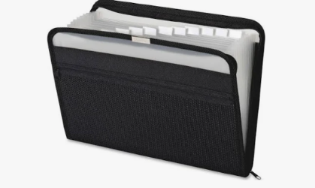

Sincerely,

Mrs. Deagostino, Mrs. Lynch, and Mrs. Siegel J