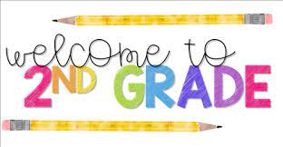  
**Supply List**  
2024-2025 School Year

Dear Second Grade Families,

Welcome to the 2024-2025 school year! We are going to have a great 2nd grade year! Listed below are the supplies your child will need for the upcoming school year. Please reach out if you have any questions, enjoy your summer and I look forward to seeing you in September!

***Needed for in school:***

* 1 rectangular (5”X 8”) school supply box
* 2 packs of #2 ***sharpened*** pencils (Ticonderoga brand if possible)
* 3 dry erase markers
* 1 box of crayons (24 or less)
* 1 pack of colored pencils (24 or less)
* 5 glue sticks (no liquid glue)
* 1 pair of student scissors
* 1 folder (pockets at the bottom)
* 1 set of headphones in a zip lock bag (labeled with name)
* Reuseable water bottle (labeled with name)

***OPTIONAL:*** Small hand sanitizer, Clorox Wipes, Zip lock bags (sandwich and gallon bags)

***Thank you!***

***Mrs. Miller (***[***jmiller3@wallkillcsd.k12.ny.us***](mailto:jmiller3@wallkillcsd.k12.ny.us)***)***

***~~1 marble composition notebook~~***