KEEP YOUR CHILD HOME FROM SCHOOL IF…
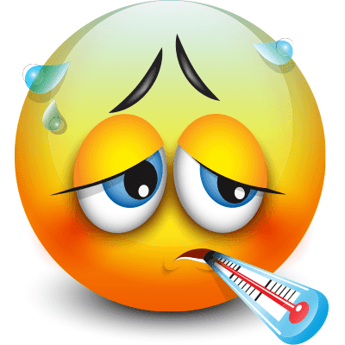 |  |  |  |  |  | 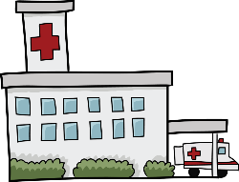
FEVER | VOMITING | DIARRHEA | RASH | HEAD LICE | EYE  INFECTION | HOSPITAL STAY &/or  ER VISIT
FEVER 100  or HIGHER | THROWING UP  WITHIN THE PAST  24 HOURS | DIARRHEA or LOOSE STOOLS WITHING THE PAST 24 HOURS | BODY RASH WITH ITCHING, FEVER, SORE THROAT or OTHER SIGNS OF ILLNESS | LIVE LICE IN HAIR | REDNESS, ITCHING, WATERY OR MUCOUSY DRAINAGE | HOSPITAL STAY or ER – URGENT CARE VISIT
** I AM READY TO GO BACK TO SCHOOL WHEN I AM:
FEVER FREE for 24 HOURS WITHOUT THE USE of MEDICATION! | NO VOMITING  for 24 HOURS  or 2 SOLID MEALS | NO DIARRHEA or LOOSE STOOLS for 24 HOURS | NO ITCHING or FEVER, or NOTE FROM DOCTOR | TREATED by LICE TREATMENT, NO LIVE LICE,  MUST BE SEEN by SCHOOL NURSE! | NOTE FROM DOCTOR “OK” TO BE IN SCHOOL | NOTE FROM DOCTOR “OK” TO RETURN TO SCHOOL!!

*IF DIAGNOSED WITH STREP THROAT, BRONCHITIS, PINK EYE, IMPETIGO or other CONTAGIOUS ILLNESS THAT REQUIRES AN ANTIBIOTIC—YOUR CHILD MUST TAKE THE ANTIBIOTIC FOR A FULL 24 HOURS BEFORE RETURNING TO SCHOOL! THEY ALSO MUST BRING IN A NOTE FROM THE HEALTH CARE PRACTITIONER THAT SAW THEM THAT SAYS THEY CAN RETURN TO SCHOOL!*
*IF YOUR CHILD HAS A COUGH THAT IS DISRUPTIVE or PERSISTENT and HAS A TEMPERATURE OVER 100.4 THEY SHOULD BE EVALUATED BY A DOCTOR. THEY ALSO MUST BRING IN A NOTE FROM THE HEALTH CARE PRACTITIONER THAT SAW THEM THAT SAYS THEY CAN RETURN TO SCHOOL!

