ECS Facilities Use Application
609-267-9172 Ext. 119
609-702-1899 Fax

Applicant’s Name __________________________________
(Please Print )
Applicant’s Address ________________________________

Applicant’s E-mail Address__________________________

Phone # ______________/_______________/______________
(Home) (Cell) (Business)

Date of Program:_____________Start Time:________End Time:________Organization:____________________________
(Please list all dates use additional sheet if needed) (Include setup time ) (Scouts-include den or troop number)

Program Purpose:____________________________________Number of Persons Attending:___________________ **All Children must be supervised AT ALL TIMES**
Number of Eastampton Residents________ Roster Attached_____

The undersigned hereby makes application for the use of: _____________________________________
(Room)
If your room request is the Cafetorium or Media Center please use diagram on back to sketch your requested layout.

Signature:___________________________________________
Insurance Requirements:

All applicants for buildings and grounds use in the Eastampton School District must meet the following insurance requirements:
- General and Automotive Liability- $1,000,000 minimum
- Worker’s Compensation - Minimum required by State
- Additional Insured - “Eastampton Township BOE and elected members, agents, servants and employees”
- The certificate of insurance must also state the following:
“The insurance afforded is primary as to any other and collectable insurance in force, with
respect to any liability arising out of the use of any Eastampton Board of Education premises
or facilities by the name insured.”

___ Insurance Certificate Attached.
**********************************************************************************************************************************************************

Hold Harmless Agreement

___________________ agrees to indemnify and hold harmless the Eastampton School District, its officers, employees, volunteers and
(Organization)
agents, from and against all claims, damages, losses and expenses, including reasonable attorney’s fees in case it shall be necessary to file an action, arising out of performance of the work herein, which is: 1) for personal or bodily injury, illness or death, or for property damage, including loss of use, and:2) caused in whole or in part or by ____________________________ negligent act or omission or that of a
(Organization)
sub-contractor, or that of anyone employed by them or for whose acts contractor or subcontractor may be liable. This indemnification and agreement shall apply in all instances whether Eastampton School District, its officers, employees, volunteers and/or agents, is/are made a
Party to the action or claim or is subsequently made a party to the action by third-party in pleading or is made a party to a collateral action arising, in whole or in part, from any of the issues emanation from the original cause of action or claim.

___________________________ ______________________________________________________________________________________
Date Signature*

*Represents knowledge of above and Use of Facilities Policy # 7510 and Regulation Guide.
Policy available on website at www.eastampton.k12.nj.us or by request.

Organization

Official Use Only

____ Application complete ______________________________________Business Administrator ___________ Date
____ Insurance Received
____ Board Agenda ______________________________________Director of Operations ____________ Date
____ Approval Letter Sent
____ Fee (If Applicable) cc: Superintendent_____ , Board of Education_____

Cafetorium
Room not available until 6:30pm

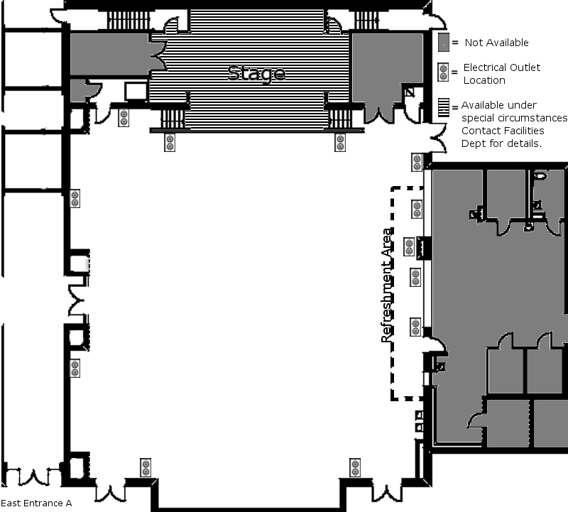

***SET-UP***

___ Podium ___ LCD Projector
___ Microphone ___ Screen
___ DVD Player ___ Table(s) number of tables _____
___ Refreshment table(s)
NOTE: Refreshment area is stationary and cannot be moved to other locations.
Media Center
Room not available until 6:30pm
