3rd Grade Trimester 1 Panther Pride Award Winners
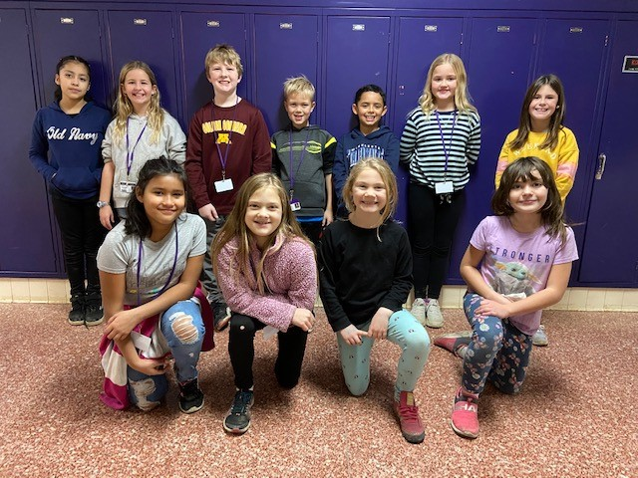
Front Row: Matilde Vargas, Aven Taylor, Esmae Aldrich, Zuri Kraft
Back Row: Deniess Guillen Caballero, Emilia Roskamp, Calvin Alsleben, Garrett Axt, Alex Garcia, Taylor Foss, Maredith Eiler Missing from the photo: Odin Richey

4th Grade Trimester 1 Panther Pride Award Winners
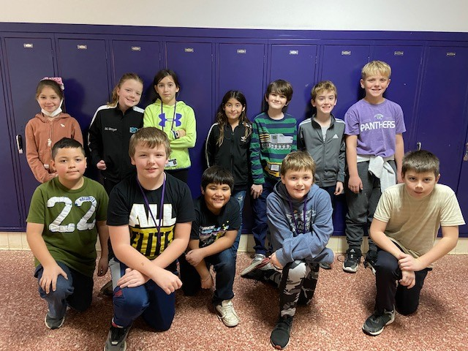
Front Row: Gael Yepez, Nolan Dammann, Eduardo Bravo-Martinez, Jase Wanous, Heinrich Vanderlinde
Back Row: Gaby Gamez Gonzalez, MaKynna Breyer, Maci Hodges, Sofia Reyes Lopez, Max Beste Zehnder, Noah Brinkmann, Mitchell Zajicek

5th Grade Trimester 1 Panther Pride Award Winners
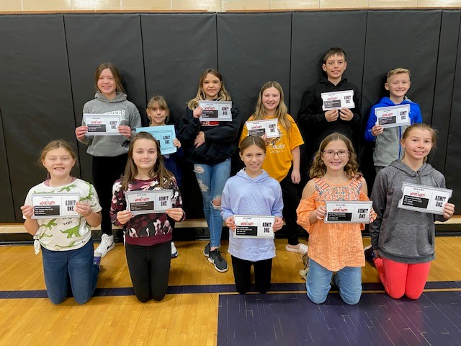
Front Row: Solveij Aldrich, Macie Clabots, Abby Eiden, Peyton Zellmann, Ashley Schauer
Back Row: Peyton Lightfoot, Mena Feltmann, Madelynn Quigley, Avery Neubarth, Noah Strobel, Maddox Varpness
Missing from photo: James Worm

6th Grade Trimester 1 Panther Pride Award Winners
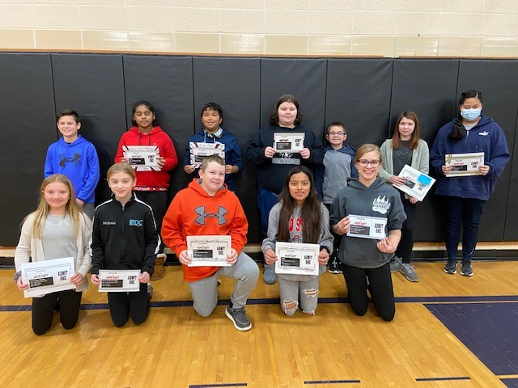
Front Row: Drew Schuette, McKenna Lindahl, Matt Barlau, Brittany Perez Velazquez, Emma Olson
Back Row: Luke Becker, Yasleen Ignacio Manzanares, Jordon O’Dell, Sammie St. Martin, Skyler Ross, Lily Clunis, Itzabela Marentes Cordero

