1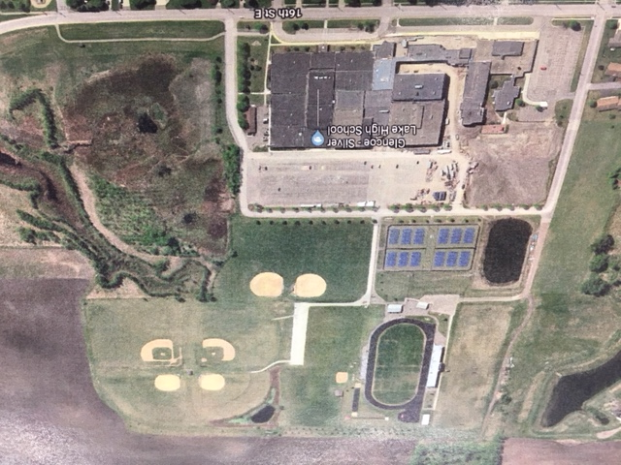
A15
A8
A7
A2
A16
A14
A13
A12
A11
A10
A1
A5
A3
A4
A9
A6
GLENCOE A1 GSL Jr./Sr. High School – 1825 E. 16th St. Glencoe
A2 GSL Lincoln Elementary School – 1621 E. 16th St. Glencoe
A3 Stevens Seminary Stadium Football / Soccer / Track
A4 GSL North Tennis Courts
A5 GSL South Practice Football / Soccer Field
A6 GSL North Practice Football / Soccer Field
A7 South Football/Soccer Field
A8 North Soccer Field
A9 South Baseball / Softball Field
A10 South Baseball / Softball Field
A11 North / West Baseball Field
A12 North / East Baseball Field
A13 North / West Softball Field
A14 North / East Softball Field
A15 Football/Soccer Field
A16 Lincoln Baseball/Softball Field

Outdoor Drop off Area

Indoor Drop off Area

