1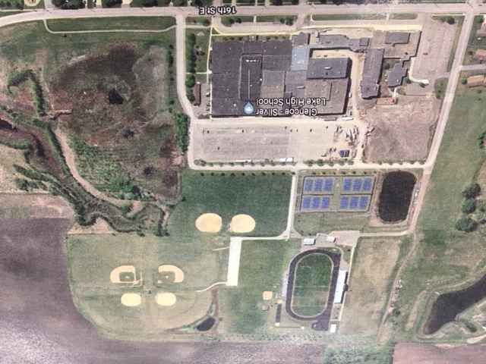

A15

A8

A7

A2

A16

A14

A13

A12

A11

A10

A1

A5

A3

A4

A9

A6

**GLENCOE** A1 GSL Jr./Sr. High School – 1825 E. 16th St. Glencoe

A2 GSL Lincoln Elementary School – 1621 E. 16th St. Glencoe

A3 Stevens Seminary Stadium Football / Soccer / Track

A4 GSL North Tennis Courts

A5 GSL South Practice Football / Soccer Field

A6 GSL North Practice Football / Soccer Field

A7 South Football/Soccer Field

A8 North Soccer Field

A9 South Baseball / Softball Field

A10 South Baseball / Softball Field

A11 North / West Baseball Field

A12 North / East Baseball Field

A13 North / West Softball Field

A14 North / East Softball Field

A15 Football/Soccer Field

A16 Lincoln Baseball/Softball Field

Outdoor Drop off Area

Indoor Drop off Area