

**6A Math Summer Packet**

**For students entering 7th grade Course 1 math in the fall**

The summer math packet is comprised of important topics that you have studied this year, and will need to recall and use in the fall.  Use your notes from the year, and any online reference as needed to refresh your memory.  If you run into a question or two on a topic that you did not study in particular, use what you do know to try to work through it to the best of your ability.

Please work on the packet in small chunks throughout the summer, NOT IN ONE SITTING.  Working in this way will best help you reinforce and retain the information that you learned this year.

After an in-class review of the packet questions, there will be a quiz on these topics during the first week of school in the fall.  Working on this packet seriously will ensure retention of the topics learned, and a good start to the next school year. There will also be a quiz on basic math computation facts during the first two weeks of school.

*** PLEASE PRACTICE YOUR MULTIPLICATION FACTS UP TO 13 X 13 EACH DAY ***

Have a safe and wonderful summer!



**THIS PAGE LEFT INTENTIONALLY BLANK.**

**6A Math Summer Packet Name: ____________________________**

**(students entering 7th grade Course 1)**

Write the place of the underlined digit. Then write its value.

1. 5, 476, 807, 139

2. 9. 478

Write the word name for each number.

3. 12,025,617,809

4. 20,000,000

Align. Use rounding to estimate each number first. Then add **or** subtract.

5. 41,132 - 17,545

6. $357.97 + $689.80

Find the product.

7. 9

x 300

8. 502

x 305

Use rounding to estimate each number first. Then multiply.

9. $2.81

x 340

10. 742

x 343

Estimate the sum using compatible numbers.

11. 23 + 19 + 24 + 17

12. $32.54 + $29.43 + $30.21

Write four related facts using the given numbers.

13. 6, 8, 48

Divide and check. There could be a remainder.

14. 372 ÷ 3

15. 32,200 ÷ 34

16. 39, 719 ÷ 5

Write whether the given number is divisible by 2, 3, 4, 5, 6, 9, and/or 10.

17. 6570

Use the order of operations to compute

18. 7 + (19 - 2) x 3

List all the factors of the number. Tell if the number is prime or composite.

19. 32

Use a factor tree to find the prime factorization of each. Use exponents when any factors repeat.

20. 128

Find the GCF of each set of numbers.

21. 16 and 48

Write the fraction in simplest form.

22. 18

63

Find the LCM of the set of numbers. (Least Common Multiple)

23. 3, 4, and 9

Write the fraction as a mixed number in simplest form.

24. 37

7

Estimate the sum using compatible numbers.

25. 0.93 + 1.1 + 1.08 + 0.9

Use rounding to estimate each number first. Then find the product.

26. 9.2

x 39

Find the product (REAL ANSWER).

27. 24.6

x 2.3

28. 1.2 x 0.04

Divide and check.

29. 25.72 ÷ 4

30. 9.5 ÷ 5

Add. Then write each sum in **simplest form**.

31.

32.

33. 5 1 3 1 4 1

+

+

=

3 12 6

Subtract. Write the difference in simplest form.

34.

35. 7 8 5 3

-

=

9 4

36. 10 + 3 2 =

8

Multiply. Write each product in simplest form.

37. 2 1

x

3 3

38. 15 x 9 =

10

39. 3 1 5

x

=

8 7

40. 2 1

3

x 3 =

41. 2 1 4 2

x

=

3 3

42. 6 x 1 =

2

Divide.

43. 12 ÷ 2 =

3

44. 7 ÷ 2 =

5

45.

46. 2 1 ÷ 4

=

2 9

47. 2 1 ÷ 1 1 =

5 10

48. 24 5

6

÷ 4 3

4

Find the sum.

49. 0.04 + 0.23 =

50. 0.7 + 0.68 + 0.08 =

Find the difference.

51. 0.8 – 0.37 =

52. 6.04 – 3.549 =

53. 0.5 – 0.29 =

Write whether each angle is acute, obtuse, right, or straight.

54. 130°

55. 15°

56. 180 °

57. 90°

Classify each triangle as scalene, isosceles, or equilateral.

58. 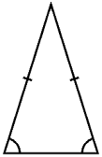

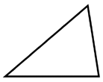59.

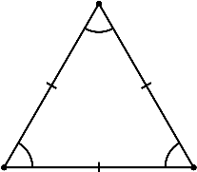60.

Find the perimeter of each polygon.

61. 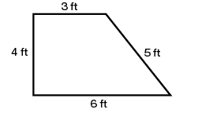

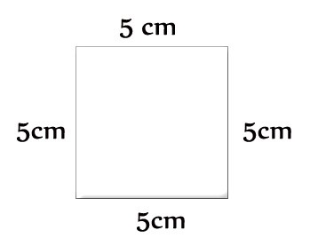62.

Write the number of sides, vertices, and angles.

63. 

Sides

Vertices

Angles

64. 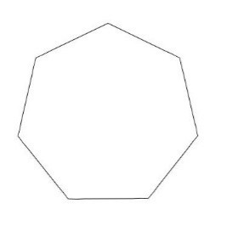

Sides

Vertices

Angles

Word Problems. SHOW ALL WORK! LOOK FOR KEY WORDS!

1. Three rivers form a river system and have lengths of 513 miles, 247 miles, and 397 miles. Altogether, how long are these rivers?
2. Jack made two stops during his 50- mile bike trip. He first stopped after 20 miles. His second stop was 15 miles before the end of the trip. How many miles did he travel between his first and second stops?
3. Ms. Chan bought 18 baskets of fruit at $10.85 a basket. Did she spend more than $200? Explain.
4. A machine produces 3360 clips in 8 minutes. How many clips does it produce in one minute?