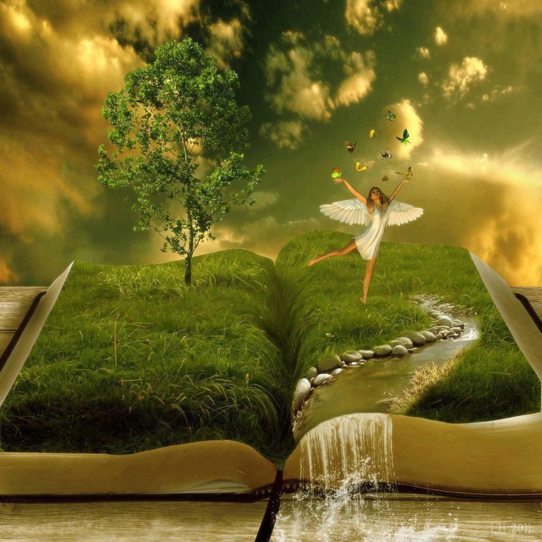

Summer Book Report #2

**Modern YA Novel**

**Your Name:**

**Date:**

* **The following pages include the 2021 Book Report Format and Summer Reading List. Directions:**
* **To demonstrate your reading comprehension, grammar, and writing skills, students will write two book reports that analyze the books read.**
* **Select two books from the Summer Reading List.**
  + **Select one book from the list of Modern YA Novels for Young Readers.**
  + **If you prefer to read a different book (at or above your reading level), you may do so.**
* **Write your Book Reports in the template provided. The questions are identical; however, you should adjust your responses appropriately depending on the book.**
* **Be Creative:**
  + **Change the picture on the template (above) to reflect your book.**
  + **Change the font style and color, but stick to 12 point.**
  + **Illustrate your report as you write it:**
    - **Include a picture of your main character.**
    - **Include a picture of the setting.**
    - **Have fun with the assignment.**

1. **Title of Book and Author’s Name**

|  |
| --- |
|  |

1. **Who is the main character? What three adjectives would you use to describe him or her? Explain in 2-3 complete sentences. (Insert a picture of your main character.)**

|  |
| --- |
|  |

1. **Name two traits you liked and two that you disliked about the main character. Use detail from the book to support your response. Respond in 3-5 complete sentences.**

|  |
| --- |
|  |

1. **Describe the setting (time and place). Does it affect the characters or the plot? Use detail from the book to support your response. Respond in 2-3 complete sentences. (Insert a picture of your setting)**

|  |
| --- |
|  |

1. **What is the main conflict of the plot? Describe how the conflict is resolved. Use detail from the book to support your response. Respond in 3-5 complete sentences.**

|  |
| --- |
|  |

1. **Did the main character learn a lesson? What was the lesson? Use detail from the book to support your response. Respond in 3-5 complete sentences.**

|  |
| --- |
|  |

1. **What do believe is the story’s main theme? Use detail from the book to support your response. Respond in 2-3 complete sentences.**

|  |
| --- |
|  |

1. **List three new vocabulary words from your reading. Write the definition and use it correctly in a sentence.**

|  |
| --- |
| **a.** |
| **b.** |
| **c.** |

1. **Would you recommend this book to others? Why or why not?**

|  |
| --- |
|  |