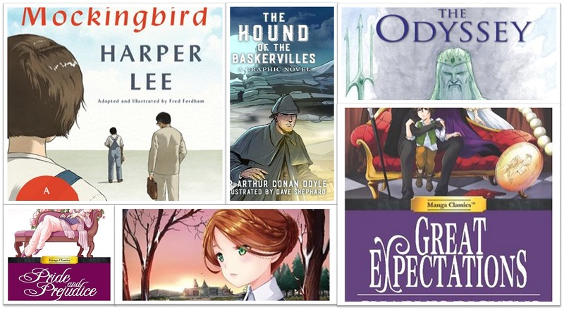

Summer Book Report #1
Classic Novel
- Your Name:
- Date:
- The following pages include the 2021 Book Report Format and Summer Reading List. Directions:
- To demonstrate your reading comprehension, grammar, and writing skills, students will write two book reports that analyze the books read.
- Select two books from the Summer Reading List.
  - Select one book from the list of Classic Novels for Young Readers.
  - If you prefer to read a different book (at or above your reading level), you may do so; however, you must read at least one classic children’s novel.
- Write your Book Reports in the template provided. The questions are identical; however, you should adjust your responses appropriately depending on the book.
- Be Creative:
  - Change the picture on the template (above) to reflect your book.
  - Change the font style and color but stick to 12 point.
  - Illustrate your report as you write it:
    - Include a picture of your main character.
    - Include a picture of the setting.
    - Have fun with the assignment.

- Title of Book and Author’s Name

- Who is the main character? What three adjectives would you use to describe him or her? Explain in 2-3 complete sentences. (Insert a picture of your main character.)

- Name two traits you liked and two that you disliked about the main character. Use detail from the book to support your response. Respond in 3-5 complete sentences.

- Describe the setting (time and place). Does it affect the characters or the plot? Use detail from the book to support your response. Respond in 2-3 complete sentences. (Insert a picture of your setting)

- What is the main conflict of the plot? Describe how the conflict is resolved. Use detail from the book to support your response. Respond in 3-5 complete sentences.

- Did the main character learn a lesson? What was the lesson? Use detail from the book to support your response. Respond in 3-5 complete sentences.

- What do believe is the story’s main theme? Use detail from the book to support your response. Respond in 2-3 complete sentences.

- List three new vocabulary words from your reading. Write the definition and use it correctly in a sentence.
a.

b.

c.

- Would you recommend this book to others? Why or why not?

