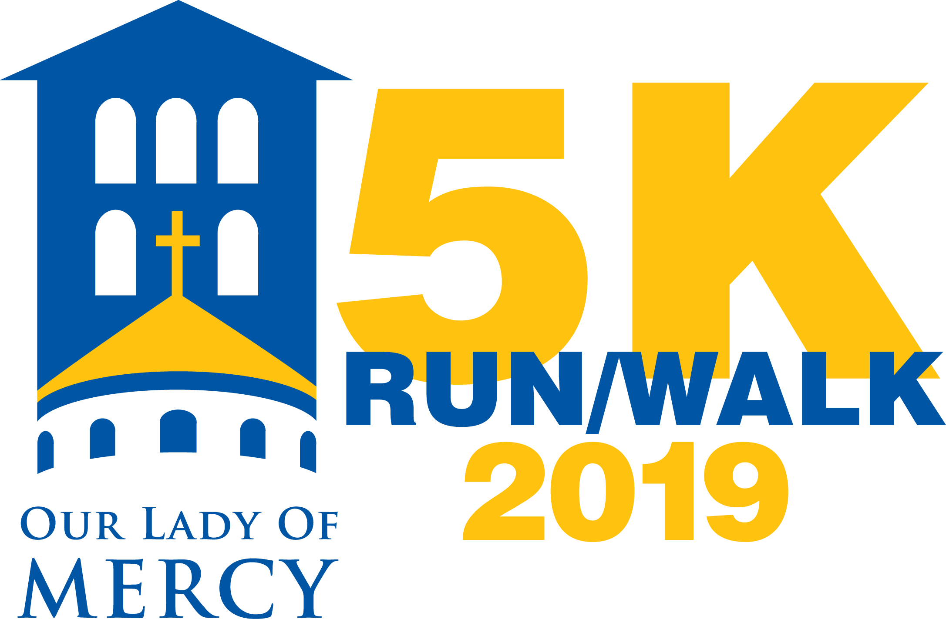

**SPONSORSHIP FORM**

MERCY 5K RUN/WALK

Saturday, November 16, 2019

Your sponsorship will benefit Our Lady of Mercy School’s Educational Fund. This fund is used for professional development and training for our teachers, innovative technology in every classroom, facility safety upgrades, tuition assistance, and delivery of individualized student instruction.

**All sponsorships must be finalized by October 25th for inclusion in promotional materials.**

**Sponsor Information**

**Company/Family Name (for signage, t-shirt and website listing):**

**Address:**

**Representative Name:**

**Representative Signature:**

**Email: Phone:**

I understand that I need to provide full payment and a company logo by October 25, 2019 in order to participate fully in all promotional opportunities described.

Signature __________________________________________

Date ______________________________________________

Please make checks payable to “Our Lady of Mercy School” and return to: Our Lady of Mercy School, 9222 Kentsdale Drive, Potomac, MD 20854.

Contact Jennifer Palmiere at [jpalmiere@olom.org](mailto:jpalmiere@olom.org) if you have questions.

**Please check the box of desired sponsorship category**

**Friends & Family - $500**

**Silver - $1,000**

**Gold - $2,500**

**Platinum - $5,000**