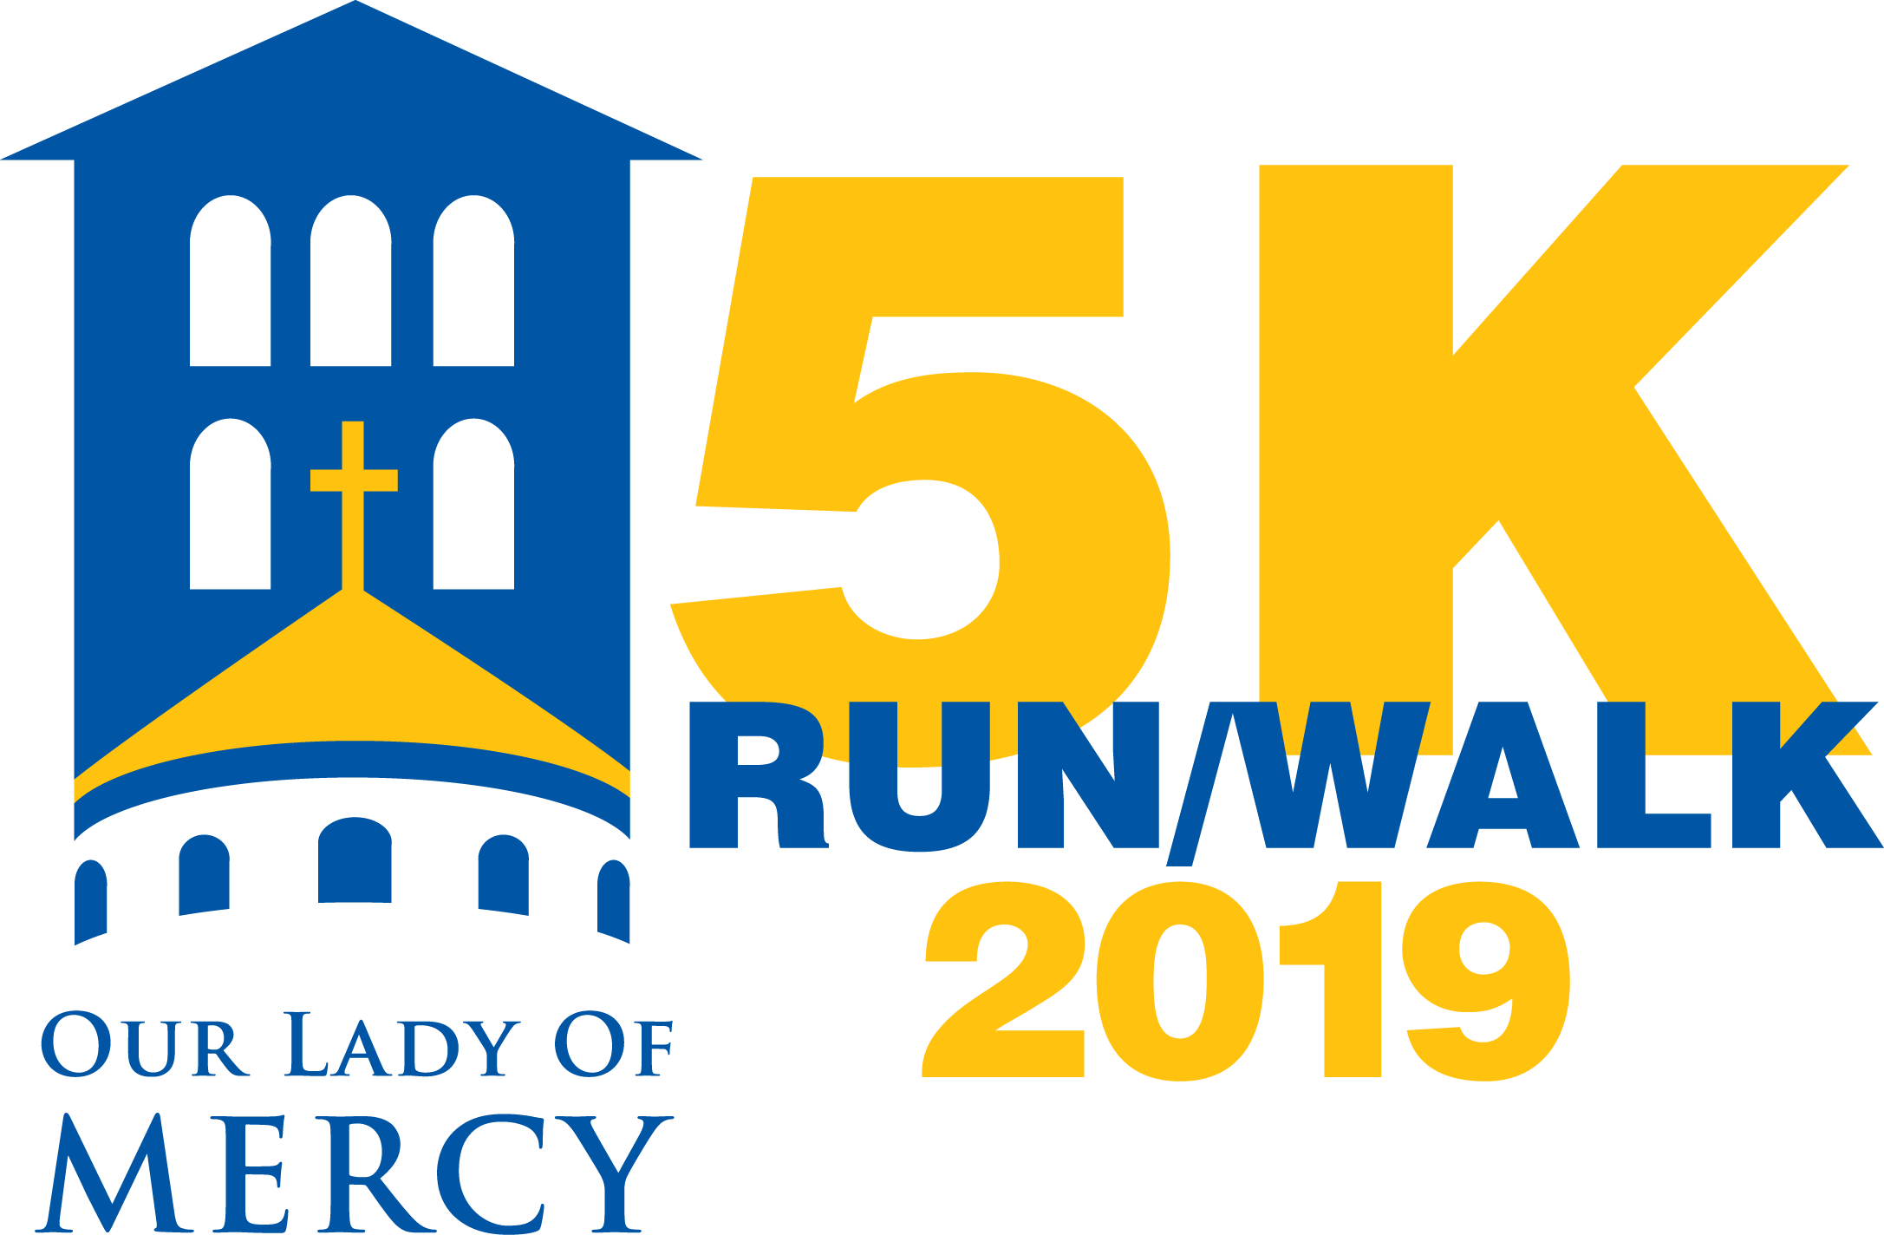

**SPONSORSHIP PROGRAM**

**MERCY 5K RUN/WALK**

November 16, 2019

**All Sponsors of the Race:**

* Will be listed on the official Mercy race website: [www.schoololom.org/5K](http://www.schoololom.org/5K)
* Will be listed on the sponsors’ poster at the post-race event
* Will be recognized in the Mercy parish bulletin, the school newsletter, and social media sites.

**Platinum Sponsor**

**Cost: $5,000**

* Race Banner – Your organization’s name/logo will have a prominent position on the banner located at the corner of Bradley and Kentsdale for one week before and after race day.
* Race Shirts – organization name or logo (large) on 5K race shirts distributed to all runners and volunteers.
* Registrations – your organization will receive 4 complimentary registrations to run in the 5K or Kids Dash
* Prominent logo display on 5K website with pass-through link
* May send us promotional material to include in the race “swag” bags
* Will be invited to set up a table at the post-race event

**Gold Sponsor**

**Cost: $2,500**

* Race Banner – Your organization’s name/logo will be included on the banner located at the corner of Bradley and Kentsdale for a week before and after race day.
* Race Shirts – organization name or logo (medium) on 5K race shirts distributed to all runners and volunteers.
* Registrations – your organization will receive 2 complimentary registrations to run in the 5K or Kids Dash
* May send us promotional material to include in the race “swag” bags
* Will be invited to set up a table at the post-race event

**Silver Sponsor**

**Cost: $1,000**

* May send us promotional material to include in the race “swag” bags
* Will be invited to set up a table at the post-race event

**Friends & Family Sponsor**

**Cost: $500**