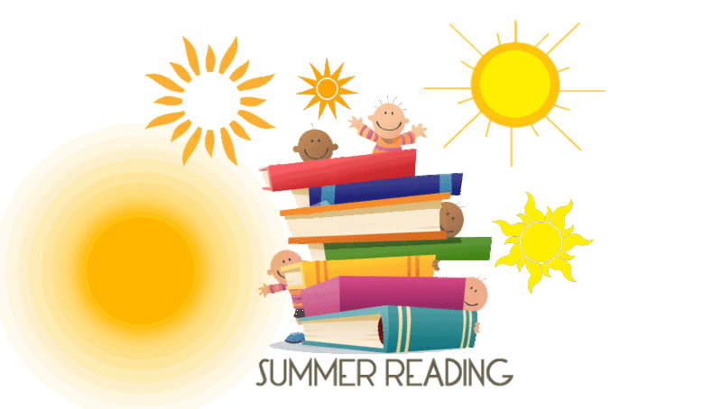

Our Lady of Mercy School
Second Grade Reading List
Summer

Reading for pleasure is key in second grade, so there are no summer book report requirements. This list includes books to be read independently, some with instructional assistance, and others that children will enjoy listening to. If your child has difficulty reading any of these books independently, I encourage you to echo read or “read along” with your child. We want this experience to be pleasurable and to foster a love of reading.

Title/Author

Dear Pope Francis: The Pope Answers Letters From Children Around the World (2016)/ Pope Francis
Who Was Mother Teresa? (2015)/Gigliotti
Willie and Me (2015)/Gutman
Hit and Miss (2015)/Jeter
The Only Game (2015) /Lupica
Just in Time, Abraham Lincoln (2014)/Polacco
Freedom’s School (2015)/ Ransome
Poetry for Young People: Robert Frost (2014)/Schmidt
Poems to Learn by Heart/Kennedy
Where the Sidewalk Ends (Poetry)/Silverstein
Our Library/Bunting
The Eagles are Back (Nature)/George
Fables (Caldecott 1981)/Lobel
Make Way for Ducklings (Caldecott 1942)/McClosky
Mirette on the High Wire (Caldecott 1993)/McCully
Me…Jane (Caldecott Honor Book 2012)/McDonnell
Mama Miti/Napoli
Grandfather’s Journey (Caldecott 1994)/Say
Many Moons (Caldecott 1944)/Thurber
Jumanji (Caldecott 1982)/Van Allsburg
A Beach Tail/Williams
Grumbles from the Forest: Fairy Tale Voices with a Twist/Yolen
Click, Clack, Peep! (2015)/Cronin
Amelia Bedelia (I Can Read Book Series)/Peggy Parish
The Case of the Spooky Sleepover, Jigsaw Jones Mystery #4/ Preller
Flat Stanley/ Brown
Lilly's Purple Plastic Purse/Henkes
Stellaluna/ Cannon
Zelda and Ivy/Kvasnosky
The Case of the Weird Blue Chicken/ Cronin

Series Books

Junie B. Jones Series
Step into Reading Books
Cam Jansen Mysteries/Adler
Matt Christopher Series/Christopher
Amber Brown Series/Danziger
Magic Tree House Series (Science)/Osborne
Animal Ark Series
National Geographic Readers Series
Geronimo Stilton/Dami
Who Was? Series
Dork Diaries/ Russell
Big Nate/Pierce
Diary of a Wimpy Kid/Kinney
Captain Underpants/Pilkey
Ivy & Bean/Barrows
Mercy Watson/ DiCamillo

Caldecott and Newberry winners are just a click away!

http://www.ala.org/ala/mgrps/divs/alsc/awardsgrants/bookmedia/caldecottmedal/caldecottwinners/caldecottmedal.cfm

Document the books you read this summer by filling out the Summer Reading Log. Return completed log to Ms. Wyble in the fall and receive a prize! ☺
