Science Course Policies

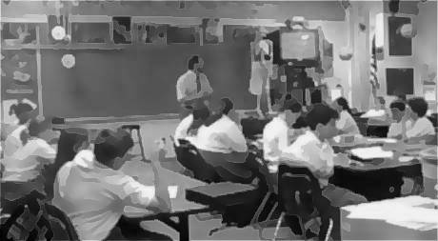

***Student questions and interests are an essential part of the class.* Lessons will be explored using a mixture of lab experiences, video, outlining, demonstrations, discussions, note-taking, computer simulations, projects, online research, text readings, and written exercises.**

***TESTS (about 50-60%) :***

**\* *QUIZZES*  are focused on limited notes, weighted 75-100 pts, and given on  *2 days notice* .**

***\* SECTION TESTS* cover a part of a chapter, weighted 150-200 pts., and with *3 days notice*.**

**\* *CHAPTER TESTS* cover ONE chapter, weighted 250-300 pts., and with *a week notice.***

***DAILY WORK ( about 40-50%) :***

**\* *NIGHTLY REVIEW* of the current section is ALWAYS ASSIGNED!**

**\* *WRITTEN ASSIGNMENTS* : weighted 20-40 pts., GRADED, and 15-20 minutes.**

**> *FULL CREDIT* : complete, neat and done according to directions.**

**> *MISSED ASSIGNMENTS* MUST BE MADE UP for (60%) credit.**

**> *PARTIAL CREDIT* if NOT neat or according to instructions.**

**\* *CLASS PARTICIPATION (100 pts.)* :determined by the contributions made  
 in class and having all needed materials.**

**\* *CLASS Notes& Folder (75-150 pts.)* : are complete /organized /formatted.**

**\* *PROJECTS AND LABS* *(100-250 pts)* : must show understanding of   
 scientific concepts, problem solving, and the ability to follow instructions.**



http://64.26.26.45/images/imagelib126/AN892.gif**Points to Remember:**         
          **1. *Respect the rights of others to learn and teach.*****2. Sequence of consequences: a) general remark, b.) warning, c) detention slip, d)detention**  
   **3. Safety first in the science room and school.**  
**4. Arrange early for extra help*.*****5. Approach teacher individually with individual concerns*.*****6. Remain in assigned areas of the school.**  
**7. Have all materials needed for class every day*.*  
          8. Keep your classroom, books, and the school neat.****9. A DAILY REVIEW  IS ALWAYS YOUR ASSIGNMENT.**   
***Student Responsibilities:* 1. Keep all graded papers to ensure an accurate grade.**  
 **2. Be sure to copy down all assignments.**  
 **3. If absent, get all make up work the *1st* day back .**  
 **4. For full credit, work neatly and follow directions.**  
 **5. Keep all text books covered and the room neat.**  
 **6. *Never* copy work (except notes) from another student.  
 7. Come to school in the proper uniform ( 3 time results in detention ).  
*Science Homework Policy***

**1. Assignments *or review* of science  *is to be done every night*2. *DAILY REVIEW is absolutely necessary!*   
3.Late assignments will receive a maximum of 60%  
4. Assignments are posted on WEB SITE AND IN SCIENCE NOTEBOOK  
5. *ONE DAY per day absent* will be allowed for making up work  
6. Labs/projects must be *complete and punctual* to receive full credit  
7. Excluding absences, *8% is lost* each school day a *PROJECT/ LAB* is late   
8. Missing assignments CANNOT be made up *after the chapter test is taken***