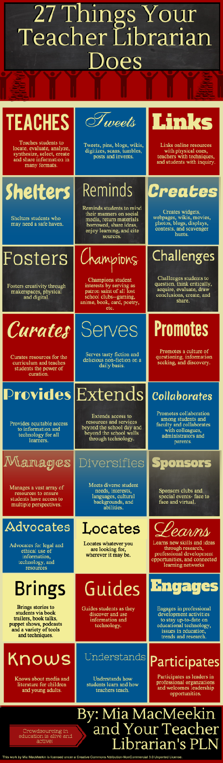

Library Media Services Login Information

Follett Destiny

<http://wgsd-follett.webster.k12.mo.us>

UN: lastname.firstname

PW: staff (ask your librarian to change it)

World Book: (8 products)

<http://worldbookonline.com>

Login for home use

UN: wgsd

PW: home

Ebsco

<http://search.epnet.com>

Login for home use

UN: wgsd

PW: wgsd

Heritage Quest

<http://www.heritagequestonline.com>

no login required

Individual libraries have other databases – talk to your librarian.

eBooks

Accessible through Follett Destiny

Login and then either conduct a keyword search with eBooks as a limiter or go directly to the FollettShelf. You must be logged in to check them out.

Simultaneous Access eBooks: Can be used by anyone at any time – no need to checkout.

eBook Reader for tablets and phones

Go to your app store and find ‘Follett Digital Reader’. You can also download a mobile version of the catalog database called ‘Destiny Quest’.

WGSD Address Book

Edline

<http://www.edline.net>

Login

Create an account at first login

Google Cloud

[www.google.com](http://www.google.com) or [www.wgcloud.org](http://www.wgcloud.org)  
Login    
UN: Lastname.firstname@wgcloud.org

PW: 12345678 - the first time you log in.

SIS

<https://sis.webster.k12.mo.us>

Login  
UN: lastname.firstname

PW:

Home access to eMail

<https://mail.wgmail.org/owa>

Use your district login to access

Technology Help Request Desk

<https://www.myschoolbuilding.com/myschoolbuilding/msbdefault.asp?frompage=/myschoolbuilding/myitdrequest.asp>

Staff Intranet (tech stuff)

<https://www.edline.net/pages/WGSD/Faculty_Staff/StaffNet>

Human Resources

<http://www.webster.k12.mo.us/pages/WGSD/Departments/District_Departments/Human_Resources>

Library Media Resources

<http://www.webster.k12.mo.us/pages/WGSD/Departments/District_Departments/Library___Media_Services>

Curriculum

<http://www.webster.k12.mo.us/pages/WGSD/Departments/Curriculum>

District Curriculum Server

<http://portal.webster.k12.mo.us/>

Use your district login to access