National Junior Honor Society
Candidacy Packet
2022-2023

Based on your academic performance and behavior since the beginning of sixth grade, you are eligible to apply for membership in the Fayette Middle School Chapter of National Junior Honor Society. Membership in NJHS is one of the highest honors that can be awarded to a student. Our chapter strives to give practical meaning to the Society’s standards of scholarship, leadership, service, citizenship, and character.

These five ideals will be considered as the basis for your selection as well as a fundamental part of our chapter activities. The National Junior Honor Society strives to recognize the total student—one who excels in these areas. No student is inducted simply because of a high academic average. Please note that though you are eligible to apply, you have not been accepted into the organization yet. Applications must be reviewed by the NJHS Faculty Council to determine acceptance of new members.

If you are chosen to be inducted as a member of the Fayette Middle School Chapter of the National Junior Honor Society, you must maintain the standards utilized for your selection. Please be aware that you:

- Must maintain a cumulative, overall middle school average of 89 or 3.4 GPA and have no failing final grades in any courses.
- Must have been enrolled for at least a semester.
- Must abide by the Chapter’s By-Laws noted on the Fayette Middle School website,
- Demonstrate sound and effective leadership, admirable citizenship, and trustworthy character at Fayette Middle School and in the community.
- Pay the chapter dues of $20 prior to your induction (after acceptance into NJHS)
- Must participate in and have a ride to the NJHS Chapter community service projects in the Fayette area

Dismissal Procedures:
A student in NJHS:
- May be dismissed from the chapter for failing to complete and to provide documentation of 10 hours of community service and school service each semester.
- May be placed on probation for receiving an N or U in conduct or a disciplinary referral
- May be placed on probation for having three unexcused absences from NJHS meetings or service projects-excuse note must be provided to advisor for consideration within five days of absence.
- May be dismissed from the chapter for committing any offense classified by the FCSD Discipline Management Plan considered as being a Level 2 or above disciplinary offense
- May be dismissed from the chapter by being placed at the district’s disciplinary alternative education program/campus or expelled from school
- May be dismissed from the chapter by having any documented incident of cheating and/or plagiarism
- May be dismissed from the chapter by having any incident of computer violations
- May be dismissed from the chapter by having any incident of dishonesty, vandalism, unethical and/or immoral behavior

If you have any questions about the obligations of being an NJHS member or about the application process, please see one of the NJHS advisors or your principal.

Sincerely,
Jacklyne Dodd
Cameron Canterbury
NJHS Adviser(s)

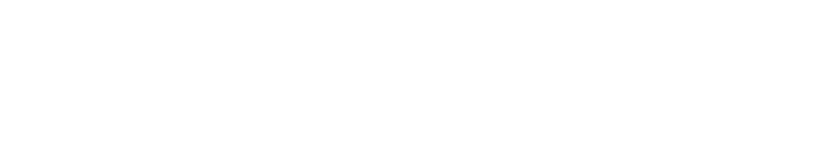

National Junior Honor Society
Fayette Middle School

Welcome! We would like to congratulate you on your outstanding academic performance. This is the first step in your application process to be inducted as a member of the National Junior Honor Society. To be considered for membership, you must complete the following. Pay careful attention to instructions and deadlines. We have included a Candidate Selection Rubric on how you will be evaluated.

Student Activity Information Form. This form is two pages long. This must be printed neatly in blue or black ink. We recommend you make a copy of this form before you begin; you might make a mistake on the first try.

Letter of Recommendation. This must be a one-page (250 words maximum) letter from an adult in the community who knows you well. The letter must include the person’s phone number and must be signed. This letter cannot be written by a Fayette Middle School staff member or one of your relatives. When requesting your letter, we recommend you ask the person to evaluate you on the five traits of NJHS: character, scholarship, leadership, service, and citizenship.

Subjective Letter. This letter must be typed by the student in business letter format. This is a one-page letter (250 words maximum) in which you show how you currently represent the characteristics of NJHS— character, scholarship, leadership, service, and citizenship--and how you can use these qualities to contribute to the overall success of the organization.

Teacher Evaluations/Teacher Signature Form. You must have three teachers complete a teacher evaluation form. Please allow your teachers time to complete this evaluation by giving it to them as soon as possible. The last day to give evaluation forms to your teachers is January 13, 2023. Do not procrastinate!!! Fill in any blanks on the forms before handing them out. As you give each teacher your evaluation, ask him or her to sign and date the appropriate box on the Teacher Signature Form verifying that they received it. Teachers will submit the recommendation forms directly to us, so you will not include them in the packet you turn in to us; however, you will include the Teacher Signature Form in your packet. An average of the three evaluation scores will determine your points earned for this category.

Keep all completed application materials in the envelopes you received from Ms. Dodd and Mrs. Canterbury. You will turn in all your paperwork together. Your complete file is due to Ms. Dodd and Mrs. Canterbury on or before January 13, 2023. You will be given only one packet. If you lose any of the pages, you may find them on our FMS website under Guidance: https://www.fayette.k12.al.us/domain/402 under “National Junior Honor Society.

Make sure you follow all directions exactly and pay close attention to deadlines. If you do not turn in all pieces by these dates, then you will not be considered for membership. Good luck. We wish you success in this and all your endeavors.

Jacklyne Dodd and Cameron Canterbury
NJHS Adviser(s) for Fayette Middle School

National Junior Honor Society
Fayette Middle School

Candidate Selection Rubric

_____________________________
Student Name

Student Activity Sheet  At least one school activity each year (5th, 6th & 7th grade) |  |  |  |  |  |  | 5 points
At least one community activity each year (5th, 6th & 7th grade) |  |  |  |  |  |  | 5 points
At least one honor or award listed (5th, 6th OR 7th) |  |  |  |  |  |  | 5 points
Additional activity listed in any of the three areas |  |  |  |  |  |  | 5 points
Total Points Possible |  |  |  |  |  |  | 20 points

Subjective Letter  Correct business letter format is used (one page; maximum 250 words) | 5 points
Explain how you currently represent the characteristics of NJHS (1 point for each characteristic) | 5 points
Explain how you can use your qualities to contribute to NJHS | 5 points
Overall quality of writing | 5 points
Total Points Possible | 20 points

Letter of Recommendation  Total Points Possible | 20 points
Teacher Evaluations  Total Points Possible | 25 points

Citizenship  No referrals |  |  |  |  |  | 15 points
1 minor referral (cell phone 3rd time, tardy, etc.) |  |  |  |  |  | 10 points
2 minor referrals or 1 major referral |  |  |  |  |  | 0 points
Total Points Possible |  |  |  |  |  | 15 points

*You must score at least 85/100 points and be approved by the Faculty Council
to be selected for initiation into NJHS.

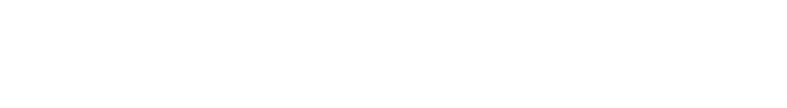
National Junior Honor Society
Fayette Middle School

STUDENT ACTIVITY INFORMATION FORM

Directions: Please complete all sections. Do not be modest. This is your time to shine. Every bit of information can be used to assist with the selection process. COMPLETION OF THIS FORM DOES NOT GUARANTEE SELECTION. Be sure to include this in your completed packet with the required signatures.
Print Neatly

Student Name: ____________________________________________
Parents’ E-mail Address(es): __________________________________________________________

Your e-mail address: _______________________________________________________________
(We send many reminders through email and/or Remind app.)

- School Activities:
  - List all activities in which you have participated in school. Include:
(1) school clubs such as Student Council, Spanish Club, Art Club, etc.
(2) school sports’ teams such as football, basketball, volleyball, etc.
(3) school activities such as Jump Rope for Heart, talent shows, etc.

  - If you held an elected or appointed leadership position in these activities, tell which position you held (secretary, team captain, etc).

  - Mark the grade you were in when you took part in these activities. These can include 5th, 6th, or 7th grade.

School Activity | Leadership Position (If any) | 5th  Grade | 6th  Grade | 7th  Grade

- Community Activities:
  - List any activities in which you participate outside of school. You may include church groups, clubs such as Boys or Girls Club, Boy or Girl Scouts, volunteer activities such as collecting money for charity, piano, gymnastics, dance, music groups, tutoring, etc.
  - Mark the year in which you participated in these activities.

Community Activity | 5th  Grade | 6th  Grade | 7th  Grade

- Recognition and Awards:
  - List any honors or awards that you have received which would support your bid to be selected for membership in the National Junior Honor Society. Examples include, but are not limited to: All A honor roll, A/B honor roll, perfect attendance, reading or writing award, sports’ awards, contest winner, church award, scouting award, etc.
  - Indicate the year in which you received the award and tell the group or activity you were involved with.

Type of Honor or Award | Group or Activity | 5th  Grade | 6th  Grade | 7th  Grade

By my signature, I am representing that the information presented here is complete and accurate. I understand that completing this form does not guarantee selection to NJHS.

Student Signature Date

I have read the information provided by my child on this form and can verify that it is true, accurate, and complete in its presentation.

Parent Signature Date

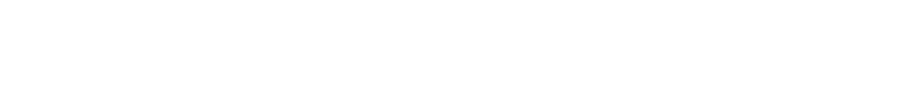
National Junior Honor Society
Fayette Middle School

Dear NJHS Candidate: As you give each teacher your evaluation form, ask him or her to sign and date the appropriate boxes. This will verify they received your evaluation on time. Fill in the Class & Teacher column before asking your teacher to sign and date.

Prospective Student Member’s Name: ________________________________________________

TEACHER SIGNATURE FORM

Class & Teacher | Date Received | Teacher Signature

National Junior Honor Society

Fayette Middle School

TEACHER EVALUATION

Teacher: _____________________________________________ Period: _____________________

________________________________________________ has been invited to join the Fayette Middle School
chapter of the National Junior Honor Society. As membership is based on more than scholarship alone, we are asking that you take a few moments and rate this student in each of the following five categories. The behaviors listed below each trait are merely guidelines to help you determine if the student meets the criteria for each one. Please use your best professional judgment. Thank you for your time.

- – Poor 4 – Above Average
- – Fair, Below Average 5--Excellent
- – Satisfactory, Average

CHARACTER 1 2 3 4 5
Displays an understanding of right/wrong
Makes appropriate choices
Treats others with respect

SCHOLARSHIP 1 2 3 4 5
Displays academic effort
Appreciates value of education
Maintains high expectations of self

LEADERSHIP 1 2 3 4 5
Displays actions of role model Leads by example
Promotes school activities

SERVICE 1 2 3 4 5
Displays willingness to help others
Assists those around them
Understands value of serving others

CITIZENZSHIP 1 2 3 4 5
Upholds school rules
Displays appropriate behavior
Appreciates spirit of community

Comments:

____________________________ Teacher’s Signature

Please return to J. Dodd by January 13, 2023.
National Junior Honor Society

Fayette Middle School

TEACHER EVALUATION

Teacher: _____________________________________________ Period: _____________________

________________________________________________ has been invited to join the Fayette Middle School
chapter of the National Junior Honor Society. As membership is based on more than scholarship alone, we are asking that you take a few moments and rate this student in each of the following five categories. The behaviors listed below each trait are merely guidelines to help you determine if the student meets the criteria for each one. Please use your best professional judgment. Thank you for your time.

- – Poor 4 – Above Average
- – Fair, Below Average 5--Excellent
- – Satisfactory, Average

CHARACTER 1 2 3 4 5
Displays an understanding of right/wrong
Makes appropriate choices
Treats others with respect

SCHOLARSHIP 1 2 3 4 5
Displays academic effort
Appreciates value of education
Maintains high expectations of self

LEADERSHIP 1 2 3 4 5
Displays actions of role model Leads by example
Promotes school activities

SERVICE 1 2 3 4 5
Displays willingness to help others
Assists those around them
Understands value of serving others

CITIZENZSHIP 1 2 3 4 5
Upholds school rules
Displays appropriate behavior
Appreciates spirit of community

Comments:

____________________________ Teacher’s Signature

Please return to J. Dodd by January 13, 2023.

National Junior Honor Society

Fayette Middle School

TEACHER EVALUATION

Teacher: _____________________________________________ Period: _____________________

________________________________________________ has been invited to join the Fayette Middle School chapter of the National Junior Honor Society. As membership is based on more than scholarship alone, we are asking that you take a few moments and rate this student in each of the following five categories. The behaviors listed below each trait are merely guidelines to help you determine if the student meets the criteria for each one. Please use your best professional judgment. Thank you for your time.

- – Poor 4 – Above Average
- – Fair, Below Average 5--Excellent
- – Satisfactory, Average

CHARACTER 1 2 3 4 5
Displays an understanding of right/wrong
Makes appropriate choices
Treats others with respect

SCHOLARSHIP 1 2 3 4 5
Displays academic effort
Appreciates value of education
Maintains high expectations of self

LEADERSHIP 1 2 3 4 5
Displays actions of role model Leads by example
Promotes school activities

SERVICE 1 2 3 4 5
Displays willingness to help others
Assists those around them
Understands value of serving others

CITIZENZSHIP 1 2 3 4 5
Upholds school rules
Displays appropriate behavior
Appreciates spirit of community

Comments:

____________________________ Teacher’s Signature

Please return to J. Dodd by January 13, 2023.

