**Alabama students can now use sunscreen at school**

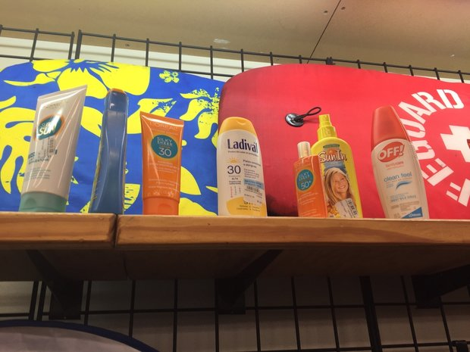

**A change in Alabama law will allow students to possess and apply sunscreen at school.**

Gov. Kay Ivey recently put her signature to bill that ends a long-standing ban on sunscreen at Alabama's schools.

[Senate Bill 63](http://alisondb.legislature.state.al.us/ALISON/SearchableInstruments/2017RS/PrintFiles/SB63-int.pdf), sponsored by Sen. Jim McClendon, R-Springville, sponsored the bill. It allows students at Alabama's public and private schools to use sunscreen despite any existing State Department of Education or Board of Nursing regulations that restrict the use of prescription and over-the-counter medications. It also makes the schools immune from liability if a student does - or doesn't - opt to apply sun protection.

Under the old regulations, sunscreen was treated as a medication and students could be required to have a doctor's note in order to possess or apply it at school. The regulations weren't enforced across-the-board, however, and some school systems allowed students to use over-the-counter sunscreen on their own.

According to the[Centers for Disease Control,](https://www.cdc.gov/cancer/skin/basic_info/sun-safety.htm)children should apply sunscreen 30 minutes before going outdoors. The use of sun block can lessen exposure to ultraviolet radiation from the sun's rays, the most common cause of melanoma, a type of skin cancer. Melanoma is the most common type of skin cancer in children, encompassing about 7 percent of all cancers in children ages 15 to 19.

Any student, parent, or guardian requesting a school board employee to apply sunscreen to a student shall present to the nurse a Parent/Prescriber Authorization form (PPA) containing a parent/guardian signature. Sunscreen must be supplied by the parent/guardian.