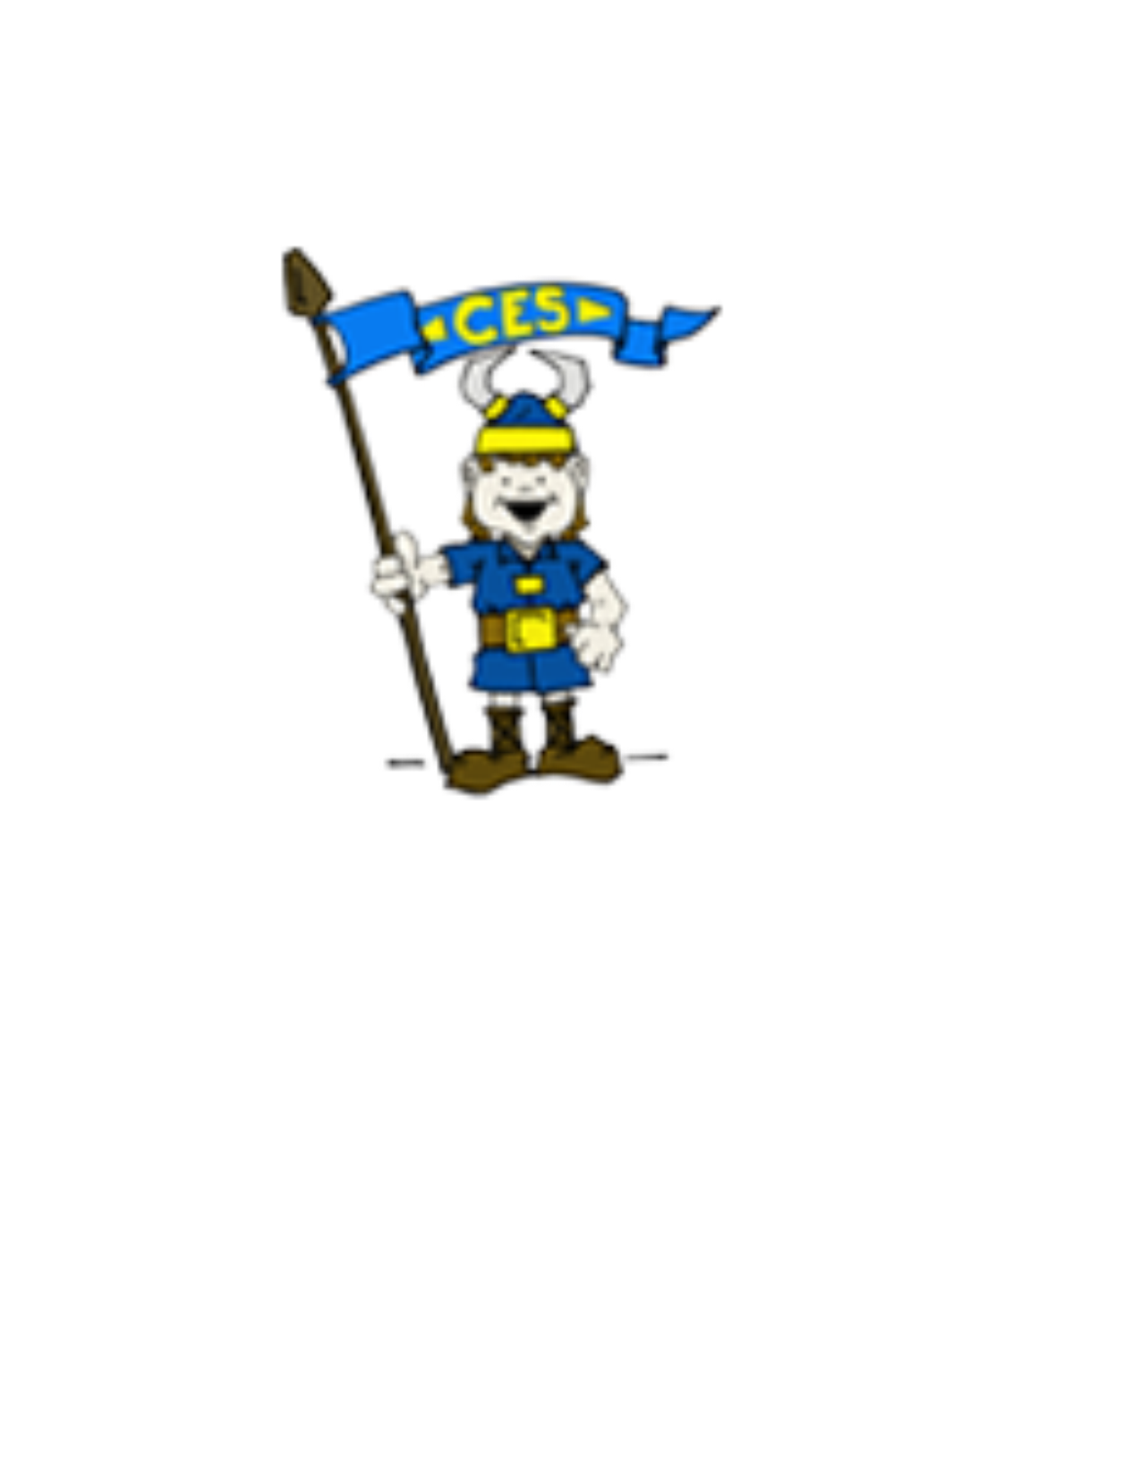Chalmette Elementary
Cultural Arts Connect Four

  Address an envelope with a Pop Up Card inside, add a stamp and mail it. |   Listen to a story from Goodnight with Dolly. Tell someone about your favorite part of the story. https://imaginationlibrary.com/goodnight-with-dolly/ | 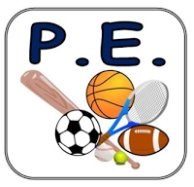  35  Mummy Walks |   Dance or “air drum/guitar to your favorite song.
Talk to your mom and ask her about what kind of music she listened to as a kid. Is it different now? | 35  Calf Raises | What is your favorite book? Why? Tell someone | Use the new skills you learned from the Pop-Ups video to make a card for Mother’s Day on Sunday, May 10th, 2020.
Ask someone to name their favorite book. Find out why they liked that book so much. | Make up new words “Mothers’ Day” to your favorite children’s song and sing it to your mom. | Use the new skills you learned from the Pop-Ups video to create a Thank You Pop-Up card for an essential worker and/or someone in the medical field. | 35  Side Lunges
35  Squat Jumps | Use the new skills you learned from the Pop-Ups video to make a Thank You Pop-Up to give to a teacher (virtually) for Teacher Appreciation Day on Tuesday, May 5th, 2020. | Watch part of your favorite movie or video without sound and think about how the sound/music changes your experience. | How do you think the book would have changed if Dolly had gotten angry about being teased by the school kids? Tell someone.

Instructions for Completion:

Students should choose one activity each day from the above selections to complete their Cultural Arts weekly assignment. As they complete the activity, they should put an “X” through that box. The goal is to “Connect Four” by completing a daily activity from each subject. Be sure to look for a new set of activities each week either on the Chalmette Elementary School website, or on one of the Cultural Arts teachers’ webpages. These will be updated each week for more fun and interesting activities.

