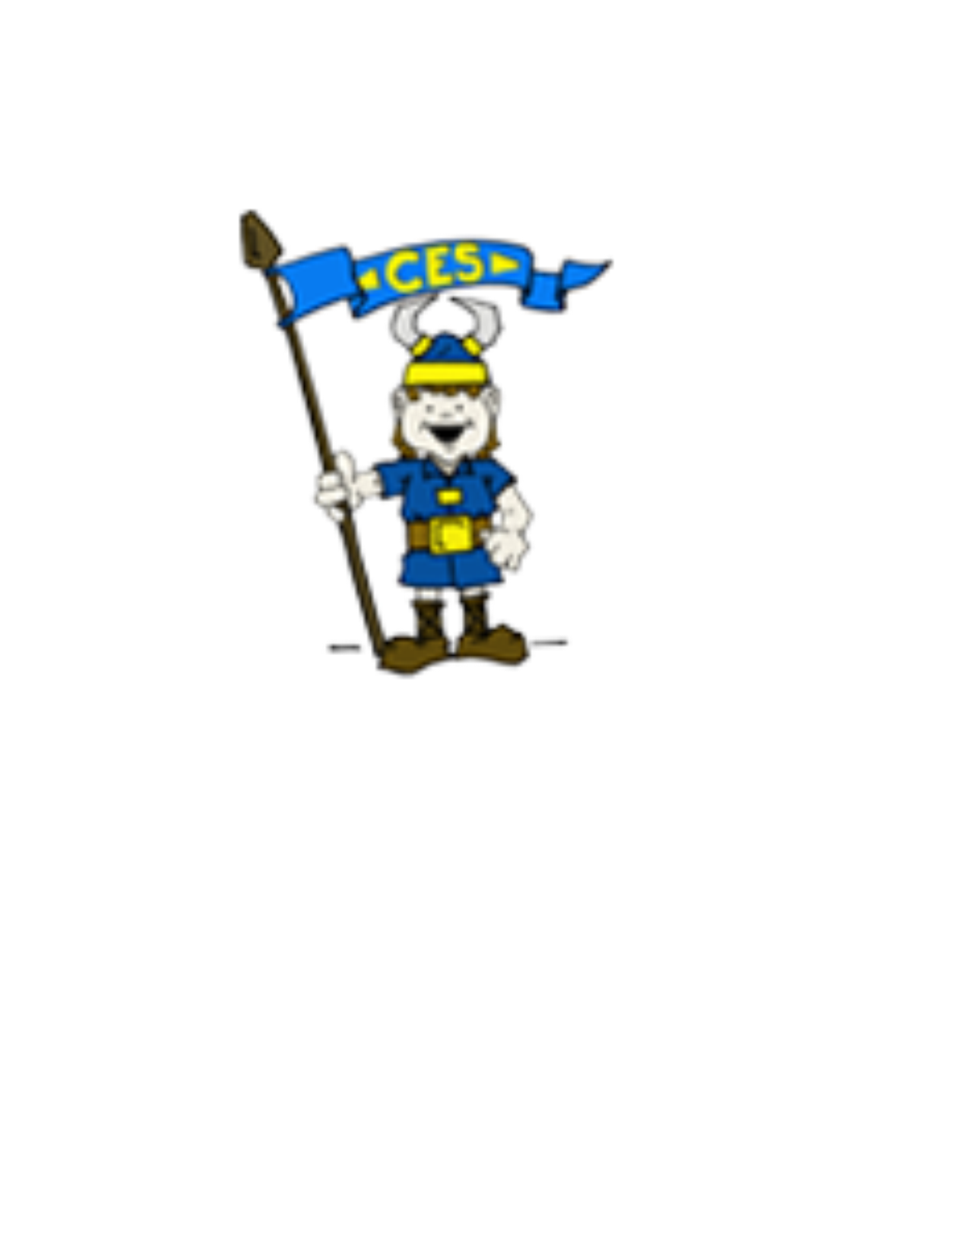Chalmette Elementary
Cultural Arts Connect Four

  Make a mandala using materials found in nature. |   The Very Hungry Caterpillar liked to eat a variety of treats. What treat do you think he liked to eat most? What kinds of treats do you like best? Tell someone three of your favorite treats. |   20 trunk twists |   Click on the link below to view ideas on how to create some other musical instruments from items in your house.  https://www.youtube.com/watch?v=7sUNXA4NYKI&t=302s
Use an instrument made from items found in your home to play along with the rhythm of your favorite song. | 20 windmills | Here is a link to a video of the author Eric Carle reading his story The Very Hungry Caterpillar. Watch it. It is less than 3 minutes long.  https://www.youtube.com/watch?v=vkYmvxP0AJI | Create a mandala using items found from around your home.
What was your favorite part of The Very Hungry Caterpillar? Why? Tell someone. | Conduct a phone or video interview with two or three of your family members who are at least 10 years older than you. Find out what was the first song they remember singing and who taught it to them. | Create a chalk drawing with radial symmetry. | 20 Push Ups
20 Power Skips | Make a design with radial symmetry by dripping water on the ground outside. | Using 2glasses with differing water levels to make a high and low pitch, and a spoon, gently tap out the song “Rain, Rain, Go Away.” (Hint: Adjust the water in the glass to change the pitch.) | Name the four stages of a butterfly’s lifecycle or draw a picture of it. Share either of these with someone using the words first, second, then, last.

Instructions for Completion:

Students should choose one activity each day from the above selections to complete their Cultural Arts weekly assignment. As they complete the activity, they should put an “X” through that box. The goal is by completing a daily activity from each subject, they will “Connect Four” Be sure to look for a new set of activities each week either on the Chalmette Elementary School website, or on one of the Cultural Arts teachers’ webpage. These will be updated each week for more fun and interesting activities.

