1. **HAND MODEL OF THE BRAIN**
2. The wrist = Spinal cord (rising from spinal column)
3. The palm = Brain stem (inner brain stem)
   1. response to danger
   2. states of arousal
   3. reactive for survival
4. The thumb folded onto the palm = Limbic region
   1. Includes the hippocampus which integrates experiences into factual and autobiographical recollections
   2. Includes the amygdala which is important in the fear response
   3. Communicates with the brain stem to create our emotions
   4. Helps us decide how to discern, give meaning, and choose
   5. Helps us form relationships
   6. Regulates the hypothalamus (the endocrine control center)
      1. Cortisol made during stress
   7. Sensitized by trauma and over-fires
   8. Helps create memories
5. Back of hand and the fingers folded over the thumb = Cortex
   1. Back of hand = back of head
   2. Fingers folded over the thumb = front and side of head
   3. From finger nails to the second knuckle = Frontal cortex
      1. Thoughts and ideas
      2. Think about thinking
   4. Middle two fingers first knuckle to fingertips = Prefrontal cortex
      1. Sense of time, sense of self, and sense of moral judgment
      2. Controls impulsivity; regulates emotions
      3. Insight and empathy
      4. Not well developed in poverty

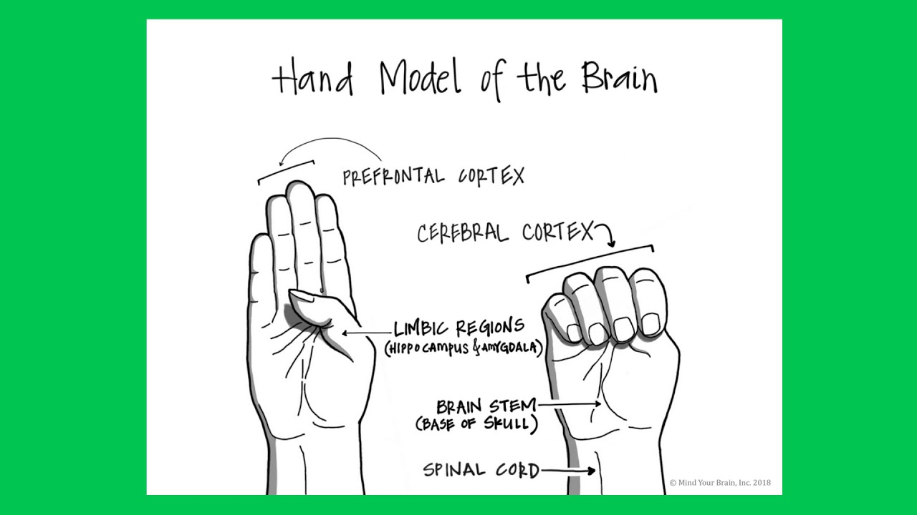

1. **THE BRAIN “MELTS DOWN”**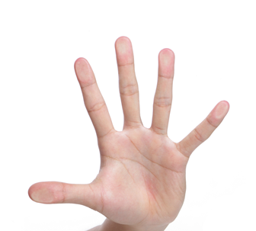
2. When the brain stem, limbic area, and the cortex all communicate with one another, vertical integration occurs. (Hand closed)
3. During an emotional meltdown, emotions are not regulated or integrated with the prefrontal cortex. (Hand wide open)
4. The middle prefrontal cortex is the part of the brain that “calms the reactive lower limbic and brain stem layers – [when it] stops being able to regulate all the energy being stirred up and the coordination and balance of the brain is disrupted…we flip our lids.”
5. When you see a student having an emotional meltdown, you are witnessing a response from an unregulated, un-integrated brain and typical discipline techniques will not work.
6. **REGULATING THE BRAIN**
7. Remember, the student’s behavior is not about disrespecting you but it is a response from an unregulated, un-integrated brain.
8. Contain the behavior by removing the student temporarily from the situation so the student doesn’t harm others
9. Use calming techniques with the student to help integrate and regulate the brain in crisis
   1. Drink a glass of water
   2. Use a “Future Story” exercise
   3. Tapping and touching
   4. Look up, look down, look side to side
   5. Deep breathing down into the diaphragm, hold for several seconds, exhale
   6. Pat your heart and stomach
10. Teach the student the hand model of the brain so they will have a mental model of what they are experiencing during an emotional meltdown.