**ACTIVITIES THAT MAKE YOUR HEART STRONG AND HEALTHY**

1. **Brisk Walking**: Need something easy and quick? Line the class up and take a quick, brisk walk, outdoors if able. Change up speeds, go slow, go fast, go left and go right, throw in some stairs if possible and head back to class to take the test.



[This Photo](http://hello-son.blogspot.com/2013_08_01_archive.html) by Unknown Author is licensed under [CC BY-NC](https://creativecommons.org/licenses/by-nc/3.0/)

2. **Recess:** Would it be possible to have a quick outdoor recess before the tests? Children are usually more physically active when loose parts are available during recess, therefore be sure to include jump ropes and balls during recess instead of just relying on playground equipment

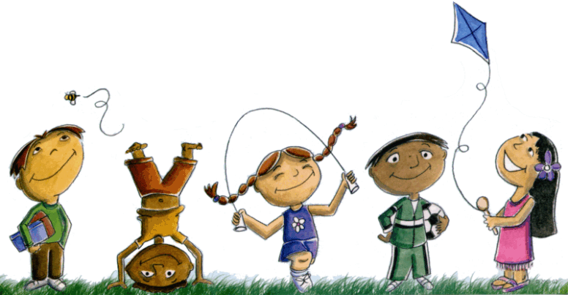

[This Photo](http://amrutam-nopen.blogspot.com/2012/07/how-my-school-made-me-what-i-am.html) by Unknown Author is licensed under [CC BY-NC-ND](https://creativecommons.org/licenses/by-nc-nd/3.0/)

3**. Chair Aerobics:** If you are tight on space and can not leave the room, turn on some music and do some quick chair aerobics. March in your seat, do large arm circles and rotate your trunk right and left.

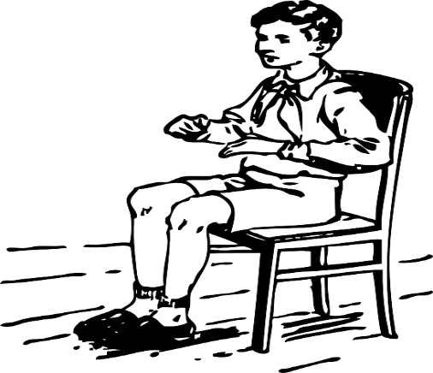

4. **Dance in Your Seat**: Again, if tight on space, turn on some music but perform the dance moves from a seated position. Do the Macarena dance sitting in a chair, stomp your feet in sitting to the ChaCha Slide, etc.



[This Photo](http://jerryachensworld.blogspot.com/2014/08/give-me-my-chair.html) by Unknown Author is licensed under [CC BY](https://creativecommons.org/licenses/by/3.0/)

5. **Shake it Out:** Stand at your seat, Call out diﬀerent body parts and the children have to shake that body part. Play it like Simon Says or move quickly calling out diﬀerent body parts to change it up.

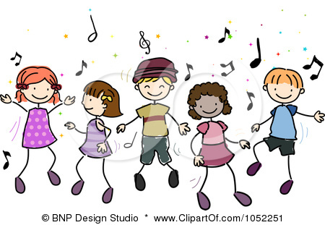

[This Photo](http://veseleklupe.wordpress.com/2012/05) by Unknown Author is licensed under [CC BY-NC-ND](https://creativecommons.org/licenses/by-nc-nd/3.0/)

6. **Classroom Cardiac Training:** Stand at your seat. Walk in place for 30 seconds, jog in place for 30 seconds, run in place for 30 seconds, jump in place for 30 seconds and ﬁnish with 30 seconds of jumping jacks.

7. **Yoga Poses:** Need to sneak in some movement but keep it calm and quiet? Try a quick yoga routine of standing poses (ie mountain pose, standing crescent pose, warrior pose, chair pose, etc).

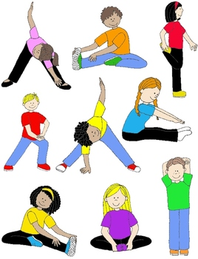

[This Photo](https://www.teacherspayteachers.com/Product/Kids-in-Action-Stretches-and-Warm-Ups-Clip-Art-18-PNGs-869484) by Unknown Author is licensed under [CC BY-ND](https://creativecommons.org/licenses/by-nd/3.0/)

8. **Animal Actions:** Move like various animals around the room.

9. **Let the Kids Lead:** Out of ideas? How about have the students take turns leading the class in some quick wake up exercises? If the kids can not think of ideas, what if they come up and demonstrate sports they participate in (ie karate, swimming, basketball, etc) and the rest of the class mimics their actions?

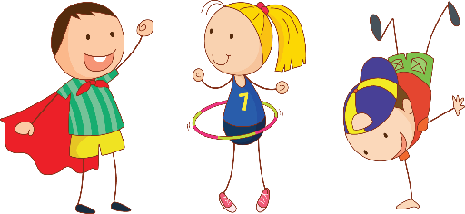

[This Photo](http://www.pngall.com/kids-png) by Unknown Author is licensed under [CC BY-NC](https://creativecommons.org/licenses/by-nc/3.0/)

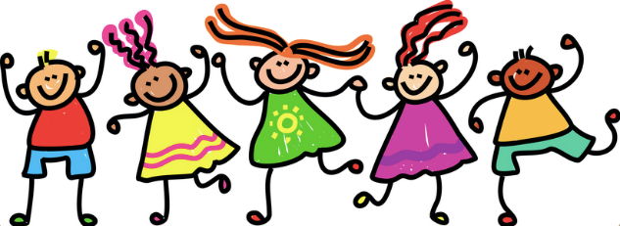

[This Photo](http://elenikyritsis.com/category/pyp/) by Unknown Author is licensed under [CC BY-SA-NC](https://creativecommons.org/licenses/by-nc-sa/3.0/)

10. **Stretch it Out:** Have the class perform some gentle stretching before they are hunched over the test for hours.



[This Photo](http://www.dailyclipart.net/clipart/boy-clip-art/) by Unknown Author is licensed under [CC BY-ND](https://creativecommons.org/licenses/by-nd/3.0/)