# **View Past Sessions**

**Would you prefer to review session data after a class is completed?**

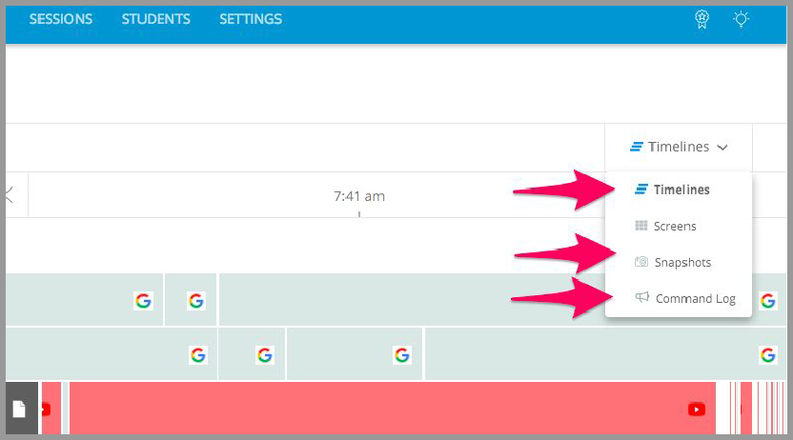Data from past sessions are available at any time on the **Sessions Tab,** organized by date and time. Open a session to **view timeline data, screenshots, and command logs**.

*For a visual walk-through of viewing past sessions data,* [*click here.*](https://help.goguardian.com/hc/en-us/articles/115005716666-View-Data-from-Past-Sessions)



**Running Student Reports**

**Would you like to run an individual report on student activity?**

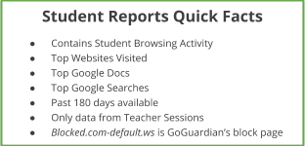**Student Reports** contain detailed records of an individual student's browsing activity during classroom sessions. The report shows browsing data recorded during an active classroom session for the selected classroom. Data recorded outside of active sessions is not available through the Teacher product but is available in GoGuardian Admin. Please contact your administrator for more information.

1. Click the menu icon to open the left sidebar
2. Under Reports, click **Student**

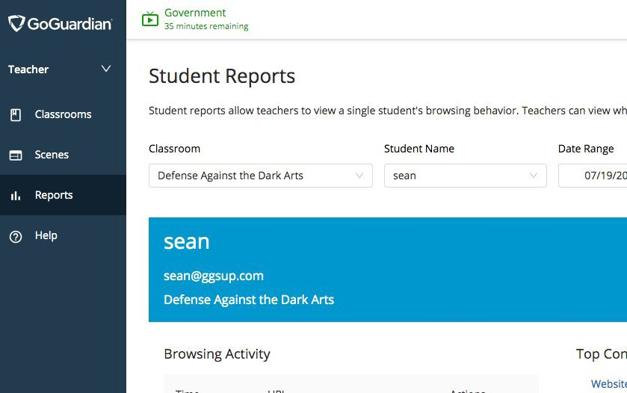**Reports**

1. Select a classroom from the drop-down menu
2. Select a student from the drop-down menu
3. Click **Apply**

*For a visual walk-through of running student reports,* [*click here.*](https://help.goguardian.com/hc/en-us/articles/360000342946-New-Individual-Student-Browsing-Reports)