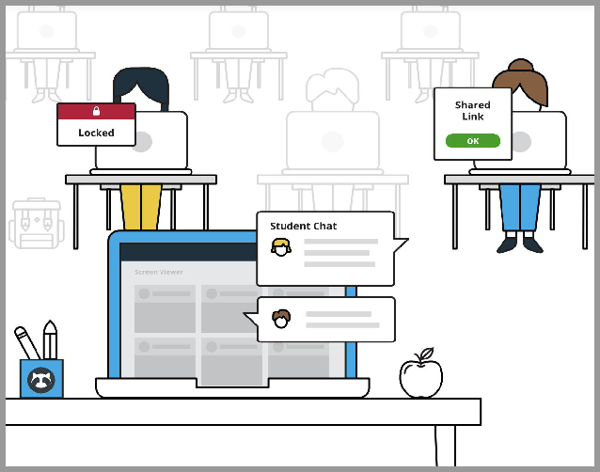**Use Teacher Commands**

#### **Teacher commands** can be used to interact with students' devices during classroom sessions!

**Do you notice a distracted student?** Send teacher commands to have some control over their device!

**Open Tab**

**Do you want to redirect students to a particular site?**

**The Open Tab** command allows you to direct an individual student or your entire class to any web page!

To open a tab:

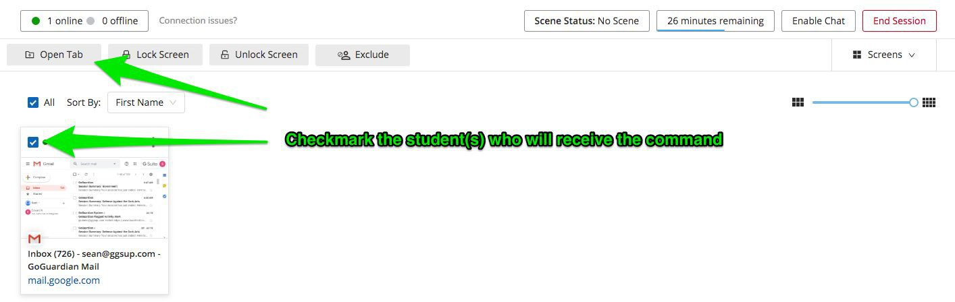

* 1. Select one or more students using the checkbox to the left of each student's name.
  2. Once students are selected, the command bar will appear at the top of the screen
  3. Click the **Open Tab** button
  4. Add a URL to the field.
  5. Click the green **Open Tab.**





# **Close Tab**

#### **Do you notice a student on a site they should not be on?**

**The Close Tab** command allows you to close tabs for your off-task students!

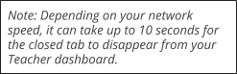To close a tab:

1. Click the screen of the off-task student
2. Identify the tab you would like to close on the list
3. Click **Close Tab** to the right of the URL

*For a visual walk-through of the Close Tab Command, please click* [*here*](https://help.goguardian.com/hc/en-us/articles/115005730683-Commands-Close-Tab)*.*

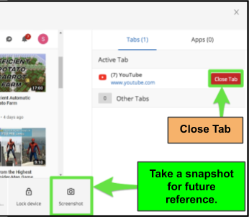**Take a Snapshot (Screenshot)**

**Notice a student off task in their browser?** Take a **snapshot** to quickly document when a student is off-task or on a site they should not be on.

#### Snapshots are saved along with other past session data on the classroom's **Sessions** tab.

To view **past session data**, see *page 12*.

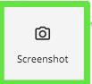

To take a snapshot:

1. Click the screen of the student
2. Hover over bottom right corner
3. Click the camera icon

To view snapshots:

1. Select the Session from the Sessions Tab.
2. Click the Timelines drop-down menu in the top right corner.
3. Click Snapshots
4. Click Download Snapshot to save.

*For a visual walk-through of the Snapshot feature, please click* [*here*](https://help.goguardian.com/hc/en-us/articles/115005730703-Commands-Snapshot-Screen-Shot)*.*

**Lock / Unlock Screen**

**Do you notice a student that should not be browsing the web at all?**

**The Lock Screen Command** will mute and disable all Chrome windows on your student's device. Send an **Unlock Screen Command** to enable their browsing again. It is recommend to unlock the student before ending your session.

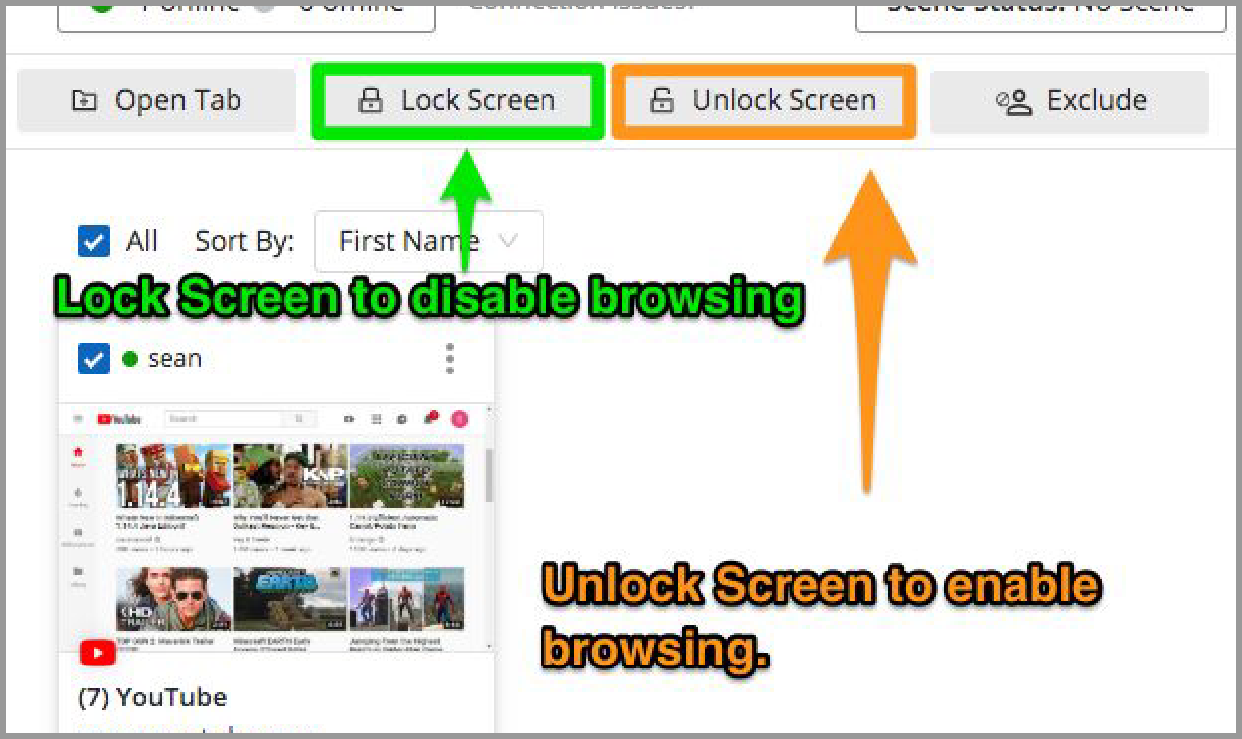

To Lock/Unlock a student’s screen:

#### Select 1 or more students using the checkbox to the left of each student’s name

1. Once students are selected, the command bar will appear.
2. Click the **Lock/Unlock Screen.**
3. Enter a custom message to be displayed for the lock screen and send!

*For a visual walk-through of the Lock/Unlock Screen Command, please click* [*here*](https://help.goguardian.com/hc/en-us/articles/115005705206-Teacher-Commands)*.*



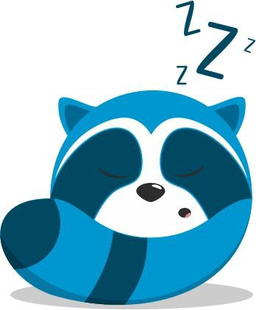\***Not sure why a student is blocked?** If the student screen does not say "browsing disabled," they may be blocked by another source. Please see [**GoGuardian Block Pages**](https://help.goguardian.com/hc/en-us/articles/115005683486) for more information